Study Of Structural And Optical Properties Of Spray Pyrolytically Deposited CuInTe_{2(1-X)}S_{2x} Thin Films
A. S. Meshram
Department of Physics, Saraswati Mahila Mahavidyalaya Saoner, 441002, Maharashtra, India
E-mail: ameshram138@gmail.com
Abstract:
The spray pyrolysis technique developed CuInTe_{2(1-x)}S_{2x} thin films of good stoichiometric for the composition of x = 0 to x = 1 at the interval of 0.25. These films were deposited on biological glass plate for various composition of x and we prepared aqueous solutions containing CuCl₂, InCl₃, TeCl₄ and (CS(NH₂)₂ respectively. From absorption spectra of the films, the band gap values are found to be 0.92 to 1.43 eV which shows the films direct allowed transition. Thickness of these films were obtained 0.16 to 0.22 µm by Michelson interferometer. We report on what we believe to be new physical properties that are relevant for photovoltaic and optical applications and summarize all relevant characteristics, both from the literature and as measured in the present work. XRD pattern shows the films is polycrystalline with preferred orientation along 112 direction. All the chalcopyrite films has attributed to copper vacancies. This paper focuses enhancement of the structural and various optical properties of commercial CuInTe_{2(1-x)}S_{2x} thin films. We have successfully obtained chalcopyrite single phase stoichiometric films. The composition of x varied from x = 0 to 1, several terms such as band gap, extinction coefficient, refractive index and real and imaginary parts of dielectric constants were extremely modified.
Keywords: Spray pyrolysis, CuInTe_{2(1-x)}S_{2x} ternary compound.
1. Introduction:
Today’s some of the major challenges for the world scientific community is to find a sustainable supply of electrical energy. There has been growing interest in the application of I-III-VI₂ ternary compound semiconductors in various electronic devices [1]. However, with an increasing population, the demands of utilization of natural resources are also increases that may cause serious energy crises in near future. The application of thin films in modern technology is widespread.
In the recent years the ternary group compounds have high conversion efficiency that exceeds 15 to 19 %. This means that CIS/Se/Te-based solar cells are able to complete with poly-si-based solar cells even though their cost of production is high. CuInS₂/CuInTe₂ are photovoltaic materials with a direct energy band gap up to 1.54 eV [2] has recently been applicable in industrial appliance [3]. Chalcopyrite-based thin film solar cell shows high performance and their highest reported efficiency is 17.8 %, and 21.7 %, for CuInSe₂ (CIS) and Cu(In,Ga)Se₂ (CIGS), respectively [4]. The microstructure of epitaxial CuInS₂, CuGaSe₂ [5] and polycrystalline CuInS₂ films has been studied by Su et al [6], examine by transmission electron microscopy process. CuInTe₂ (CIT) film shows an excellent absorber materials photoelectric property and it has smaller direct band gap varying between 0.92 to 1.06 eV [7-9] is well-adopted to the absorption of solar spectra, and its optical absorption coefficient, (10⁵ cm⁻¹) [10], a stronger quantum confinement effect and a larger Bohr radius than those of CIGS, CuInSe₂ and CuInS_{2.} Spray pyrolysis is a versatile and effective technique to deposit metal oxide films. The quality and properties of the films depend largely on the process parameters. The most important parameter is the substrate surface temperature [11].
To understand their properties, thorough understanding of the chalcopyrite crystal structure and CuInTe₂/CuInS₂ ternary chalcopyrite, binary-ternary semiconductors isnecessary [12]. Thin films of ternary compound have been prepared by several methods such as r. f. sputtering [13], co-evaporation [14], chemical bath deposition [15], electrodeposition [2] and spray pyrolysis [9,16-19]. CuInTe₂ is a direct band gap semiconductor, because of its intermediate band gap, high absorption coefficient, low resistivity and easy ohmic contact, it has found potential applications [9,19]. Thin films find applications is various devices like solar cells, space science system, optical devices, computer memory devices, opto-electronic devices, these devices made from thin film have several advantages over their bulk counterparts [11].
As the part of this study, the CuInTe_{2(1-x)}S_{2x} quarter-nary semiconducting chalcopyrite system has been selected. This work aims to prepare the above semiconducting chemical compound by spray pyrolysis method. In the present paper we have studied thickness, structural and optical properties of films with the help of Michelson interferometer, XRD data and optical transmittance data by UV Spectrophotometer shows that the prepared films have a high transparency ranging from 60 to 80% for photons having wavelength 350 nm to 1100 nm [16-20].
2. Experimental Details:
CuInTe_{2(1-x)}S_{2x} thin films used in this study were deposited by spray pyrolysis technique. The aqueous solution of 0.02 M solution was prepared as source of Cu, In, S and Te. CuCl₂ as a source Copper, InCl₃ as a Indium, thiourea for Sulphur and TeCl₄ as a Tellurium source respectively. Preparation thin films methods are details describes in several research papers [16-19]. The obtained film thickness were measured by a Michelson interferometer.
Optical properties of the obtained films were studied UV transmittance spectroscopy using a double-beam spectrophotometer (Shimadzu UV–1800) in the range of 350–1100 nm with a resolution of 0.1 nm.
3. Structural Properties
X-ray diffraction studies made on Bruker AXS D8 Advance X-Ray Diffractometer, with Cu K_{α} (λ = 1.5418 Å) radiation and maximum usable range 10 to 80 degree for CuInTe_{2(1-x)}S_{2x} thin films of all five composition parameter of x. X-ray diffraction spectra of as deposited CuInTe_{2(1-x)}S_{2x} thin films deposited on glass substrate for composition parameter x = 0, 0.25, 0.50, 0.75 and 1.0 are shown in fig (1). The observed diffraction peaks of thin film were found at 2θ values of angles 25.113⁰, 28.888⁰, 33.292⁰, 39.281⁰, 44.64 ⁰, 49.90⁰, 59.88⁰, 72.23⁰, 76.53⁰ corresponding to the lattice planes (112), (200/400), (211), (301), (116/312), (231/107), (235/413) and (420/404) respectively. It is observed that some important peaks corresponding to (112), (220/204) and (116/312) planes shift regularly as the composition parameter x changed. The performed orientation along (112) direction which confirmed the chalcopyrite structure of the films. The crystalline size was estimated from the Scherrer’s equation [9]. The X-ray diffraction studied that all diffraction peaks can be easily indexed and confirms the dominantly chalcopyrite structure of the films to a tetragonal phase [20, 21].
Crystallite Size (t) = $\frac{0.9 λ}{βCosθ}$ (1)
Where λ is the wavelength of X-rays, β is the full width half maximum, θ is the Bragg angle. The crystallite size increased 0.1 to 0.2 μm. Here, all chalcopyrite lines of CuInTe_{2(1-x)}S_{2x}thin films were shifted slightly to higher diffraction angles, resulting in decrease in lattice constant. It may due to the vacancies in crystal structure for the formation of all these thin films. Therefore, the crystalline quality of films was affected by Cu/In ratio. This may be due to the diffusion of copper atoms from the copper under layer in the CuInTe_{2(1-x)}S_{2x} layer that compensate the lack of Cu and improve the crystallinity of the films layer with composition [19].

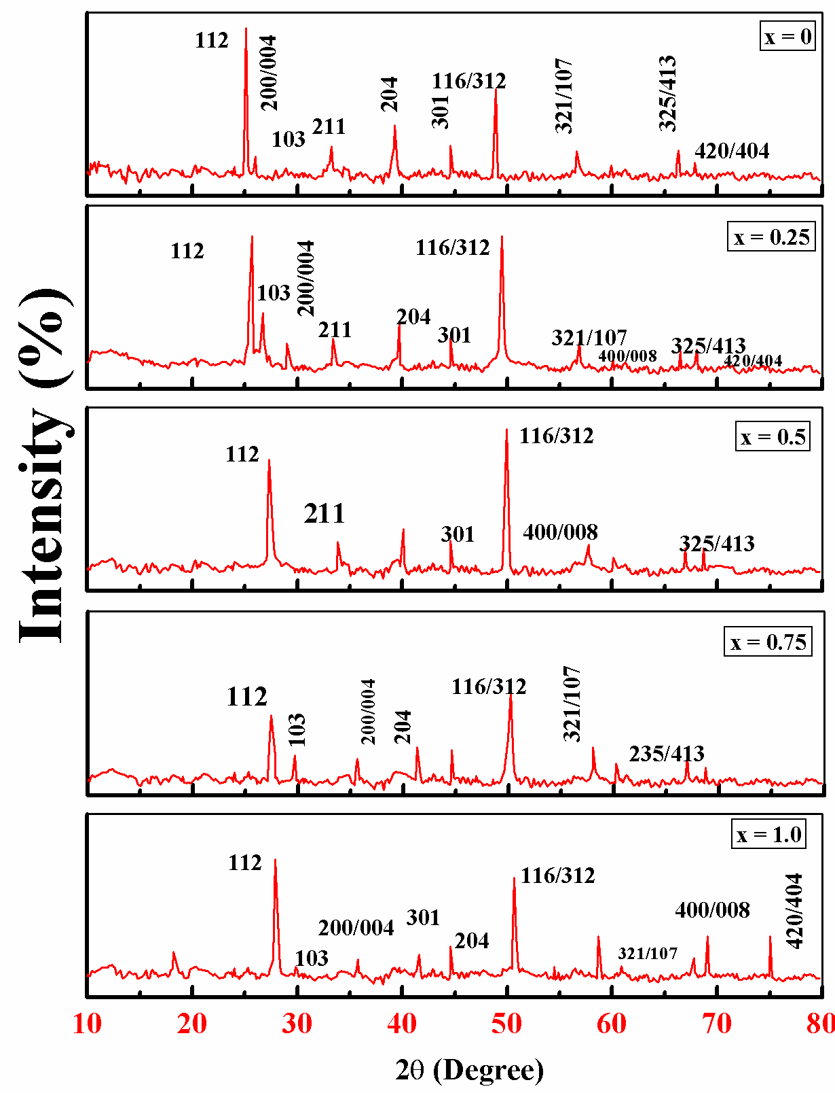
Fig. 1 X-ray diffraction pattern of as deposited CuInTe_{2( 1-X)}S_{2X} thin films for x = 0, 0.25, 0.5,0.75, 1.0

We noticed here the benefit effect of the copper under layer which plays a copper atoms tank role for the CuInTe₂ and CuInS₂ [9]. Copper oxide impurities due to the oxidation in air atmosphere that contribute to the decrease in crystallinity. These values of d compared with JCPDS data [22, 23] were examined for identification of CuInTe₂ and CuInS₂ [9, 19, 24, 25] thin films respectively. It has been shown’ that the XRD pattern of CuInTe_{2(1-x)}S_{2x} thin films powder only exhibits the most intense super lattice reflections with very low intensities. All the films were Cu poor with Indium, Tellurium and Sulphur contents near the stoichiometric composition [9], it is also seen in Cu-In precursor films. Spray pyrolysis technique prepared films has shown good stoichiometric films results reported other researchers [20].
3.1 Other Parameters (Crystallite Size (D), Dislocation Density (Δ), Internal Strain (Ε) And Number Of Crystallites Per Unit Cells (N)):
The dislocation density (δ) is defined as the length of dislocation lines per unit volume of the crystal and was calculated using Williamson-Smallman relation [26, 27],
$δ=\frac{1}{D^{2}}$ (2)
Where 1- is a factor values when the dislocation is minimum and D is the crystallite size.
The strain (ε) was calculated from the slope of β cosθ versus sinθ plot using the relation, [28]. The strain value can also be obtained from a Williamson-Hall Plot serves to indicate the magnitude of the strain distribution of a non-uniform strain states [29].
$β=\left[\frac{λ}{D cos θ}\right]-[ε tan θ]$ (3)
The internal strain (ε) was calculated using the relation,
$ε= \frac{β}{4 tanθ}$(4) OR $ε= \frac{β cosθ}{4}$ (5)
Where, β- full width of half maxima of the peak
Number of Crystallites per unit area (N),
$N= \frac{t}{D^{3}}$ (6)
Where, t- thickness of as-deposited thin films, D-grain size, crystallite Size

Table 1 X-ray diffraction data for as-deposited CuInTe_{2(1-x)}S_{2x} thin films for
x = 0, 0.25, 0.5, 0.75, 1.0
^{CuInTe}₂ |  |  | ^{CuInTe}_{1.5}^{S}_{0.5} |  | ^{CuInTe}_{1.0}^{S}_{1.0} |  | ^{CuInTe}_{0.5}^{S}_{1.5} |  | ^{CuInS}₂
^{hkl} | ^{d} | ^{I/I0} | ^{d} | ^{I/I0} | ^{d} | ^{I/I0} | ^{d} | ^{I/I0} | ^{d} | ^{I/I0}
¹¹² | ^{3.571} | ¹⁰⁰ | ^{3.529} | ^{86.2} | ^{3.396} | ⁷⁶ | ^{3.247} | ⁶¹ | ^{3.197} | ⁶⁰
¹⁰³ | ^{3.438} | ^{10.8} | ^{3.386} | ^{5.4} | ^{3.274} | ^{5.4} | ⁻ | ⁻ | ^{3.066} | ¹⁰
^{200/004} | ^{3.096} | ^{13.0} | ^{3.087} | ^{18.2} | ^{2.959} | ²⁰ | ^{2.756} | ^{11.3} | ^{2.7807} | ^{10.2}
²²⁰ | ⁻ | ⁻ | ^{2.187} | ¹² | ⁻ | ⁻ | ⁻ | ⁻ | ⁻ | ⁻
²¹¹ | ^{2.697} | ^{30.2} | ^{2.612} | ^{20.2} | ²⁵²⁶ | ²² | ^{2.488} | ^{12.3} | ^{2.421} | ¹⁵
²⁰⁴ | ^{2.205} | ^{24.2} | ^{2.120} | ^{35.6} | ^{2.034} | ^{30.5} | ^{1.999} | ^{17.5} | ^{1.960} | ¹⁸
³⁰¹ | ^{2.035} | ¹⁵ | ^{2.006} | ^{22.2} | ^{1.945} | ^{23.2} | ^{1.868} | ^{15.6} | ^{1.823} | ²²
^{116/312} | ^{1.871} | ⁶⁶ | ^{1.856} | ⁷⁰ | ^{1.816} | ⁹⁶ | ^{1.763} | ^{62.3} | ^{1.674} | ^{55.2}
^{321/107} | ^{1.626} | ^{19.6} | ^{1.619} | ¹⁵ | ⁻ | ⁻ | ^{1.651} | ^{23.2} | ^{1.566} | ¹⁵
^{400/008} | ^{1.553} | ^{10.1} | ^{1.539} | ^{10.6} | ^{1.504} | ¹² | ^{1.447} | ^{10.2} | ^{1.386} | ^{10.6}
^{325/413} | ^{1.411} | ¹⁰ | ^{1.394} | ^{6.6} | ^{1.372} | ^{18.2} | ^{1.321} | ^{12.3} | ^{1.267} | ¹⁶
^{420/404} | ^{1.380} | ¹² | ^{1.372} | ^{15.4} | ^{1.301} | ¹⁸ | ^{1.254} | ^{8.6} | ^{1.242} | ³⁰
^{316/332} | ⁻ | ⁻ | ⁻ | ⁻ | ^{1.292} | ¹² | ⁻ | ⁻ | ⁻ | ⁻

Table 2 Variation of crystallite size (D), Dislocation density (δ), Internal strain (ε) and (N) with temperature for CuInTe_{2(1-x)}S_{2x} thin films for composition of x.
x | Thickness  (μm) | Crystallite size (D)  (10⁻¹⁰) (m) | Dislocation  Density (δ)  (10¹⁰) (m⁻²) | Internal Strain (ε)  (10⁻⁶) (m⁻²) | N  (10⁸)  (m⁻³)
0 | 0.1752 | 10.4172 | 0.9214 | 3.4781 | 1.5498
0.25 | 0.1821 | 8.2776 | 1.4594 | 4.0464 | 3.2106
0.5 | 0.2012 | 8.7448 | 1.3076 | 4.1432 | 3.0086
0.75 | 0.2103 | 8.5571 | 1.3656 | 4.2341 | 3.3560
1.0 | 0.1862 | 8.1272 | 1.5394 | 4.4581 | 3.4686

All values of variation of crystallite size, strain and other micro-structural parameters with different temperature for all the proportion of x in CuInTe_{2(1-x)}S_{2x}thin films is as shown in table (2). Using equation (2-6) the crystallite size (D), dislocation density (δ), Internal Strain (ε) and number of crystallites per unit cells (N) with temperature for CuInTe_{2(1-x)}S_{2x} with composition x of thin films were calculated and tabulated values put up in table 2.
From tabulated figure of parameter in Table (2) shows that the deviation in the lattice parameter values from the bulk value observed in the present case clearly suggests that the grains in the films are under stress. Such behavior can be attributed to the change of deposition conditions and the concentration of the native imperfections developed in thin films. This results in either elongation or compression of the lattice and the structural parameters. The density of the film is therefore found to change considerably in accordance with the variations observed with the lattice constant values [30]. The crystallite size is observed to varies from about 7.2 – 11.5 × 10⁻¹⁰ m with various substrate temperature for the formation of CuInTe_{2(1-x)}S_{2x} thin films with the composition of x (0 to 1, interval of 0.25).

The strain developed at higher substrate temperatures (350⁰C) is likely to be due to the formation of native defects developed from the lattice misfit or dislocations [9]. The defects have a probability to migrate parallel to the substrate surface with the surface mobility greatly influenced by the substrate temperature so that the films will have a tendency to expand and develop an internal strain. The stress relaxation is mainly considered as due to dislocation glides formed in the films. It is also seen, the change in the calculated strain for the deposited films based on the measured shift of the (112) peak and the strain values fully depends upon the crystallite size of the films [20, 31]. The calculations show that the strain was highest for the sample deposited without additional substrate heating.
The number of crystallites per unit area (N) is found in the range (2.36-36.11)×10¹⁵m⁻² corresponding to prominent (111) orientation and observed to be increased with film thickness due to decrease in average grain size which may be attributed to the growth of smaller grains on the surface of larger grains in deposition process [32-33]. The dislocation density and internal strain are varied in the range (5.03-26.75) ×10¹⁵ m⁻² and (12.23-28.75) ×10⁻³ respectively. Murali et al [34] were well agreed to this reported result in present work and earlier by other workers [35]. There was calculated dislocation density, internal strain, crystallites size and other parameters were studied.
4. Optical Properties:
Absorption is expressed in terms of an absorption coefficient (α)which is defined as the relative rate of decrease in light energy (hν) along its propagation path, calculated graph and band gap values are reported earlier research papers [16, 19]. Band gap values were calculated from plot of (ahν)² vs hν by extrapolating the straight line from high absorption region. The band gap of about increased from 0.92 to 1.54 eV change in substrate temperature [9, 20].
It was observed that the band gap decreased with increasing temperature up to 350⁰C after that band gap values increases. This may be due to defects in the lattice and these values are in good agreement with previous results for other methods [9, 17, 20, 36].
4.1 Extinction Coefficient, Refractive Index And Dielectric Constant:
Optical measurements can also be used to study lattice vibrations (phonons). This can be conveniently taken into account by defining a complex refractive index [16],
n* = n + ik (7)
Where, n-is the refractive index and phase velocity of any materials, k-called the extinction coefficient (known as mass attenuation coefficient). The real part of the refractive index n determines the propagation velocity (ν and wavelength λ) in the medium,
n = c / v
For non-magnetic materials, we can takeµ = 1, the real and imaginary part of dielectric constant can be calculated by using the following equations,
ε = ε₁ + iε₂ = (n + ik)² (8) (n -ik)² = ε – iε (9)
Where, ε₁= n² – k² (10) And ε₂ = 2nk (11)
By using this relation, from which the absorption coefficient (α) and the real (n) and imaginary (k) part of dielectric constant were can possible to calculate [37]. The refractive index value can be calculated from the formula [38],
n = $\frac{1+R}{1-R}$ + ${[\frac{4R}{{(1-R)}^{2}}- k^{2}]}^{1/2}$ (12)
Where, R is the reflectance, the extinction coefficient, which is related to the exponential decay of the wave as it passes through the medium, extinction coefficient (k) is estimated from the values of absorption coefficient (α) and wavelength (λ),
k = $\frac{αλ}{4 π}$ (13)
Where λ is the wavelength of the incident radiation and absorption coefficient (α) is calculated by equation

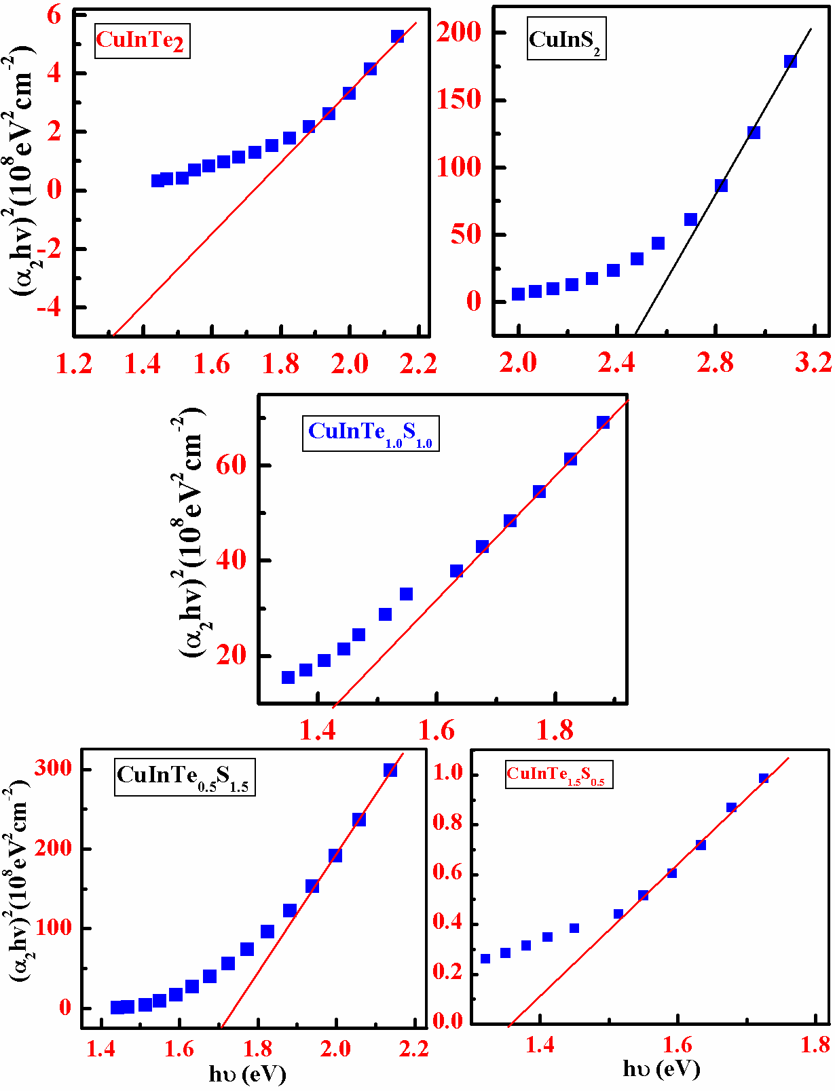
Fig 3.13 Plot of (α₂hv)² against incident photon energy (hv) of as deposited CuInTe_{2(1-x)}S_{2x} thin films for x = 0, 0.25, 0.5, 0.75 and 1.0.

It is well known that localized states near the band edge because the appearance of band tails in the film band diagram. These band tail states are responsible of the sub-gap absorption in the low energy range [39]. Using these equations (12, 13), easy to calculate the values of ‘n’ and ‘k’ respectively. The variations of refractive index ‘n’ and extinction coefficient ‘k’ with incident photon energy for CuInTe_{2(1-x)}S_{2x} thin films of as-deposited are shown in figure. Reported values are well agreed with [40] were grown thin films have a direct allow electronic transition with optical energy gap (Eg) decreased from 1.51 eV to 1.30 eV. It is also the extinction coefficient (k), refractive index (n) and the real and imaginary dielectric constants (ε₁, ε₂) have been investigated.
5. Conclusions
In this study, we have fabricated semiconducting chalcopyrite thin films by conventional spray pyrolysis method on glass substrate. We observed that thickness of the films was found between 0.16 to 0.22 μm. It is known that the thickness of the films are lighter so that light passes through the layer plays an important role in the Photovoltaic performance of the solar cells. The optical absorption study shows that the CuInTe_{2(1-x)}S_{2x} film has a direct allowed transition.
The XRD spectra of the sample showed tetragonal chalcopyrite structure with preferred orientation along 112 directions. The good crystallinity was found for all the composition parameter x. Accuracy of n and k values for these films are necessary in order to analyze the structure. In the study, we prepared films have power conversion efficiency by using CuInTe_{2(1-x)}S_{2x} films deposited using spray pyrolysis technique under normal atmospheric conditions.

Acknowledgments
Authors would like to express his thanks to Department of Physics, R.T.M Nagpur University Nagpur and Principal, Saraswati Mahila Mahavidyalaya, Saoner for providing research space and moral support.
References
1] M. Ben Rabeh and M. Kanzari, Thin Solid Films, 2011, 519, 7288.
2] H.Goto, Y.Hashimoto, K.Ito, Thin Solid Films, 2004, 451 –452, 552.
3] S. S. Gupta, M. A. Pateria, K. Deshmukh, International Journal of Engineering Technology, Management and Applied Sciences, 2017, 5 (7), 529.
4] A. Romeo, M. Terheggen, D. Abou-Ras, D. L. Ba¨tzner, F.-J. Haug, M. Ka¨lin, D. Rudmann and A. N. Tiwari, Progress in photovoltaics: research and applications, 2004, 12, 93.
5] D. Fischer, T. Dylla, N. Meyer, M. E. Beck, A. J¨ager-Waldau, M. Ch. Lux-Steiner, Thin Solid Films, 2001, 387, 63.
6] D. S. Su, W. Neumann and M. Giersig, Thin Solid Films, 2000, 361, 218.
7] M. Boustani, K. El. Assali, T. Bekkay and A. Khiara, Solar Energy Materials and Solar Cells, 1997, 45, 369.
8] D. Prasher, K. Dhakad, A. K. Sharma, V. Thakur and P. Rajaram, International Journal of Materials Science and Applications, 2004, 3 (1) 1.
9] E. Aydin, N. D. Sankir, H. Unver, E. Uluer, International Journal of renewable energy research, 2012, 2(3) 491.
10] S. Roy, P. Guha, S. Chaudhuri, A.K. Pal, Vacuum, 2002, 65, 27.
11] A. Amara, W. Rezaiki, A. Ferdi, A. Hendaoui, A. Drici, M. Guerioune, J. C. Berne`de, M. Morsli, Solar Energy Materials and Solar Cells, 2007, 91, 1916.
12] T. P. Sharma, S. K. Sharma, R. Kumar and G. Jain, International Journal of Recent Research and Review, June 2012, II, 39.
13] A. Parreta, M. L. Addonizia, A. Agati, M. Pellegrino, L. Quercia, F. Cardellini, J. Kessler, H. W. Schock, Japanese Journal of Applied Physics,1993, 32, 80.
14] A.H. Moharriam, M. M. Hafiz, A. Salem, Applied Surface Sciences, 2001, 172, 61.
15] M. Dhanam, R. Balasundaraprabhu, S. Jaykumar, P. Gapalakrishnam, M. D. Kannam, Physica Status solidi (a), 2002, 191, 149.
16] A. S. Meshram, Y. D. Tembhurkar and O. P. Chimankar, International Journal of Scientific Research in Physics and Applied Sciences, 2018, 6 (6) 34.
17] B.G. Jeyaprakash, R. Ashok Kumar, K. Kesavan, A. Amalarani, Journal of American Science,2010, 6(3) 22.
18] N. Suriyanarayanana and C. Mahendran, Archives of Physics Research, 2012, 3 (1) 54.
19] A. S. Meshram, Y. D. Tembhurkar and O. P. Chimankar, International Journal of Advance Research in Science and Engineering, 2017, 6 (9), 1735.
20] R. Guan, X. Wang, and Q. Sun, Journal of Nanomaterials, Journal of Nanomaterials, 2015, 2015 Article ID 579489, 1.
21] X. H. Xu, F. Wang, J. J. Liu, K. C. Park, M. Fujishige, Solar Energy Materials and Solar Cells, 2011, 95, 791.
22] JCPSD File Powder diffraction Data File, Joint committee of Powder Diffraction Standard, International Center for Diffraction Data, USA Card No. 34-1498.
23] JCPSD File Powder diffraction Data File, Joint committee of Powder Diffraction Standard, International Center for Diffraction Data, USA Card No. 65-2732.
24] D. Sridevi and K. V. Reddy, Thin Solid Films, 1986, 141, 157.
25] K. M. A. Hussain, J. Podder, D. K. Saha and M. Ichimura, Indian Journal of Pure and Applied Physics, 2012, 50, 117.
31] T. Hurma, Indian Journal of Pure and Applied Physics, 2016, 54, 797.
32] H. Chen, Y. Lu and W. Hwang, Materials Transactions, 2005, 46 (4) 872.
33] M. N. Al-Jabery, Q. A. Abbas, H. S. Al-Jumaili, Iraqi Journal of Physics, 2012 10(19), 70.
34] K. R. Murali, P. Muthusamy, A. Panneerselvam, Journal of Materials Science: Materials in Electronics, 2013, 24, 3412.
35] A. H. Reshak and S. Auluck, PMC Physics, 2008, B 1 (12) 1.
36] J. E. Jaffe and A. Zunger, Physical Review B, 1993, 27(8), 5176.
37] A. Kotbi, B. Hartiti, A. Ridah, P. Thevenin, Optical and Quantum Electronics, 2016, 48, 75.
38] Alaa A. AL- Jubory, International Journal of Science and Technology, 2012, 2 (10) 707.
39] S. M. Wasim, C. Rinco´n, G. Marı´n, R. Ma´rquez, Journal of Physics and Chemistry of Solids, 2003, 64, 1627.
40] D. Sridevi and K. V. Reddy, Thin Solid Films, 1986, 141, 157.

