Saur Urja – Green Energy to Greener Energy
A Photovoltaic (PV) Solar Energy Based Project

Dinesh V Kala¹ and Sanjay V Lalla²

¹ Professor G.N Khalsa College, Matunga, Mumbai-19
² Associate Professor R.K.Talreja College, Thane, Ulhasnagar-3

kaladc10964@gmail.com

ABSTRACT

Saur-Urja is exactly solar energy. The sun radiation intensity of 1365 W/m² is present outside earth in the form of UV, Visible & Infrared heat. The upper layers of the atmosphere absorb UV light with help of ozone. Finally, on earth we receive Saur Urja in the form of heat & visible light. The project is a standalone solar PV system which can be used anywhere.
Solar Photo Energy received on earth is converted to electrical power by PV panels and the energy is stored in batteries. Battery is used to run loads at night or on cloudy days. If the battery goes below a certain level for example 50% all loads switch off simultaneously. Hence there may not be sufficient battery energy to run critical loads for a longer time.
Hence, we must save battery energy so that we can run critical loads at night. The innovation was done in such a way that every load was given priority depending on critical needs. Battery was charged fully during daytime in using PV system and then it was monitored always by a sensor which gives SOC of battery. Depending on SOC of the battery and priority, load was kept on or switched off.
The lower priority loads were switched off as battery energy decreased & higher priority loads critical by nature were still running at night.

Keywords: Saur –Urja , SOC , Standalone PV System, battery and dc loads

- INTRODUCTION
Solar energy will be prime renewable energy used by mankind in years to come. The reason is that it is easy to use & results NO pollution in the atmosphere.
The storage or saving of solar energy in batteries for later use in day suffers as batteries lose energy due to internal resistance. Only 80% -90 % of the battery's energy can be used.
It is a well-known fact that DC loads like LED lamps, DC fans consume less power compared to AC loads.
Hence needed energy to run critical DC loads for a longer time and at night from the battery in the PV standalone system was understood. Hence battery energy must be saved at any cost.
Under this project an embedded system is designed & introduced between battery and loads so that one can monitor loads depending on their priority. It depends on the user to decide how much energy can be used so that loads can remain on for a longer time.
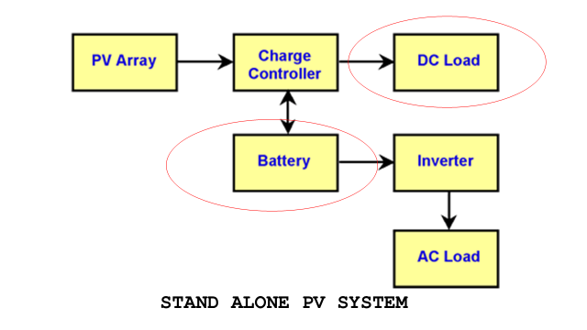

- METHODOLOGY
The design included measuring the SOC of the battery. The battery voltage level was used to measure SOC. When the battery is full (SOC-100%) and when half (SOC- 50%) difference is divided into four levels as one uses four loads only.
Each level was assigned to load and were run in sequence depending on their priority. The assignment of priority of loads is done through a python. Loads are given priority in ascending order numbers. The higher the number least is priority for that load. The program in the microprocessor controls the DC loads in an energy efficient manner. The sensor used to give information about the battery state of charge. The sensor analog output is converted to digital data by ADC and is processed by an appropriate algorithm in the microcontroller.
Microprocessor or Microcontroller then monitors the DC appliances or loads on a basis of priority or importance of loads. Least priority load automatically gets cut-off when battery voltage falls below a certain pre-set limit. The process continues for the other loads in order of priority till next day when the sun energy is again available to Solar Panels.

- EXPERIMENTATION

3.1 Material and Methods
- The following hardware components were used
- Solar panel of 100W (12V/8.33A) to tap solar energy into electricity
- Charge controller (12V/10A) provides controls charging of battery
- Battery storage – Sealed Lead acid battery (12V/7AH)
- Microprocessor – Raspberry pi -3 model B+ has linux os
- ADC 8951- serial communication with Raspberry pie
- Optocouplers 817- helps separation of relays with main microprocessor
- Driver Transistors 8040 drives 4 Relays (12V, 2A)
- Sensors –battery voltage divider circuit
- Four DC Loads (All led lamps)

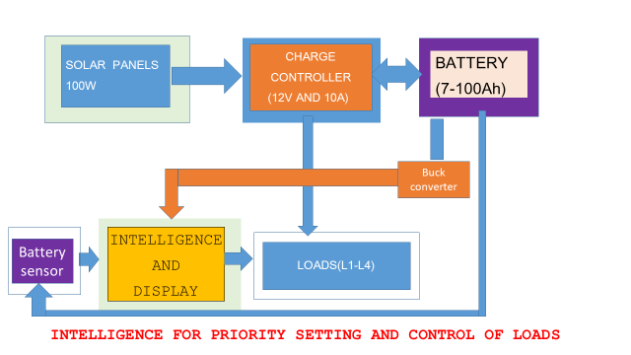
- PROCEDURE -An embedded system designed and assembled as shown in fig -2 to observe how one can run critical loads for more time with priority concept .The priority was set initially in python program and microprocessor Raspberry pie can controlled the loads efficiently as loads were made switched off when battery voltage felled below certain level . The wastage of energy was minimized by saving the energy for critical loads in night time.

- RESULTS -
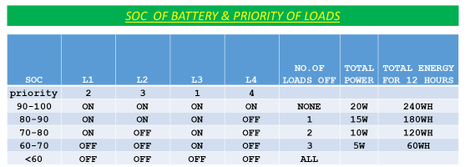
- DISCUSSIONS
The project will be useful in all major development of renewable energy projects. The renewable energy also should be used effectively & efficiently. The project's major use will be in making smart cities, power provided certain sectors like railways, hospitals, industrial, offices and residential will be priority dependent. In buildings we may use solar power for water pumps and critical appliances fans during summer. In hospitals ICU and general wards power to them will be priority dependent.

CONCLUSIONS
Energy management at the consumer end by controlling the loads will help the consumer to participate and share the responsibility in proper management of energy. Saving energy for important loads has become important. Hence, we should give priority to loads in ascending order and run accordingly. It maximizes the energy savings along with the reduction in cost of energy consumption.

- REFERENCES
- Solar-electricity basics by Danchiras, new-soceity publishers
- Photovoltaics for dummies Shaum series
- Photovoltaics Practical Handbook of Photovoltaics: Fundamentals and Application Augustin McEvoy.
- Clean Electricity from Photovoltaics Archer, Mary D.; Hill, Robert.
- Photovoltaics: Fundamentals, Technology and Practice Mertens, Konrad; Hanser, Karl Friedrich.
- Photovoltaics System Design and Practice: System Design and Practice Haberlin, Heinrich.
- Electricity from Sunlight: An Introduction to Photovoltaics Lynn, Paul A.
- Solar Energy Engineering: Processes and Systems Kalogirou, Sotiris.
- Solar Energy: Technologies and Project Delivery for Buildings Walker, Andy
- Solar Cells and Their Applications Lewis M. Fraas and Larry D. Partain

