e-CALLISTO Data Analysis Using Python Scripts

DNYANDEV B. PATIL¹, VIJAY S. KALE², A. D. SHALIGRAM³

¹Department of Electronics, LVH College, Panchavati, Nashik, Maharashtra, India. -422003
²Principal, Arts and Commerce College, Makhamalabad, Nashik, Maharashtra, India-422003
³Formal HOD, Department of Electronics, Pune University Pune-422003
dnyaneshpatil20@gmail.com

Abstract
The continuously changing solar wind, geo-magnetic field from the Sun and the plasma flow has high impact on the life of the living organism. The living organism life on the earth is driven by the Sunlight. The climate of the earth is critically sensitive to the solar activities. This impact is very high when sun is following 11-year cycle. Therefore, it becomes necessary to observe and study the solar activities. Many instruments and observatories are watching the solar activities. Compound Astronomical Low-cost Low-frequency Instrument for Spectroscopy and Transportable Observatory (CALLISTO) is portable and low-cost instrument used to detect solar activities. e-CALLISTO network with central hub located at the Switzerland is worldwide network and providing observations from different countries from last several years. The received data is raw with noise and in the Flexible Image Transport System (FITS) file format. This data needs processing by the suitable image processing techniques. There are different methods that can be used to process the generated images. The main aim of the image processing is to remove the background noise from the image. This paper presents the processing of FITs file by python scripts. Python programming language works quickly and integrates systems more effectively. The advantages of python scripts are its flexibility of the command, convenient and short script, fast data processing. The script uses minimum resources and time to process single image. This is useful when large numbers of images are needed to be processed with limited computer resources. Paper represents the radio burst results after Python script processing of images received by e-CALLISTO (Nashik-India) recently.

Keywords: e-CALLISTO, Image processing, data analysis, FITs file, Python script

- Introduction

The continuously changing solar wind, geo-magnetic field from the Sun and the plasma flow has high impact on the life of the living organism. The living organism life on the earth is driven by the Sunlight [1]. The climate of the earth is critically sensitive to the solar activities. This impact is very high when sun is following 11-year cycle [2]. Therefore, it becomes necessary to observe and study the solar activities. Many instruments and observatories are watching the solar activities. Compound Astronomical Low-cost Low-frequency Instrument for Spectroscopy and Transportable Observatory (CALLISTO) is portable and low-cost instrument used to detect solar activities. e-CALLISTO network with central hub located at the Switzerland is worldwide network and providing observations from different countries from last several years [3]. From last 3 years we are observing the solar activity by usisng callisto instrument and a LPDa located at KTHM College. The observations are mostly solar flares of different groups sunch as type I type II type III, type IV, type V etc. [4]. The received data is raw with noise and in the Flexible Image Transport System (FITS) file format. There are 169 e-CALLISTO instruments located at different places in the world. For installation LPDA, LNA, CALLISTO instrument and a Computer is required (http://www.e-callisto.org/GeneralDocuments/ Callisto-General). There are different methods that can be used to process the generated images [5].

The first description of the Earth's magnetic field was given by De Magnete, William Gilbert, in the 16th century, showing that the Earth itself is a great magnet [6]. Gauss and William Weber studied Earth’s magnetic field that showed organized variations and random fluxes, that suggested the Earth was not an isolated body, but also was influenced by external forces called magnetic storms [7].

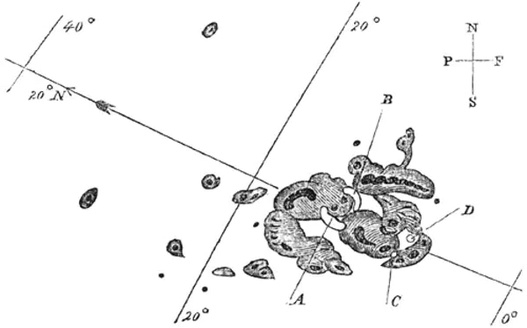

Fig.1. Sunspot Sketch Drawn by Richard Carrington

Richard Carrington on 1st September 1859 observed first powerful magnetic storm. He drew the sketch of the Sunspots shown in figure 1. The concluding line about is that solar flares happens frequently, especially at the time of maximum sunspot and sun is following 11-year cycle [8].

Most of the emission are because of plasma emission at low frequencies. Every emission is separate in their spectrum and chronological behavior. They can best be distinguished in spectrograms. A sudden brightening across all atmospheric layers in the solar atmosphere dissipating energy. This energy is stored magnetically in the corona preceding to the event which builds up taking place as the result of deep-seated convective motions that deliver high magnetic pressure in the form of magnetic fields. The solar flares produce radiation over the electromagnetic spectrum with different intensity. These can be observed by various methods [9].

The generated files are in the form of FITs file. This data needs to be processed by the suitable image processing techniques. The main aim of the image processing is to remove the background noise from the image. This paper presents the processing of FITs file by python scripts. Python programming language works quickly and integrates systems more effectively. The advantages of python scripts are its flexibility of the command, convenient and short script, fast data processing. The script uses minimum resources and time to process single image. This is useful when large numbers of images are needed to be processed with limited computer resources. Paper represents the radio burst results after Python script processing of images received by e-CALLISTO (Nashik-India) recently.

- Experimental Work
Figure 2 shows block diagram of callisto station located at Nashik. The data is stored locally on HDD of computer.

Computer
Tower Mounted Amplifier
CALLISTO instrument

Figure 2. block diagram of e-callisto station.

Computer is running on windows 10 with updated software. The callisto is controlled with callisto.exe software. This software features generating of FITs file of interval of 15 minutes. These files are stored on local hard drive and also transmitted over network to central hub located at Zurich University, Switzerland.

  - Python Script
Python script is used to process the generated FITs files.
    - Flow Chart
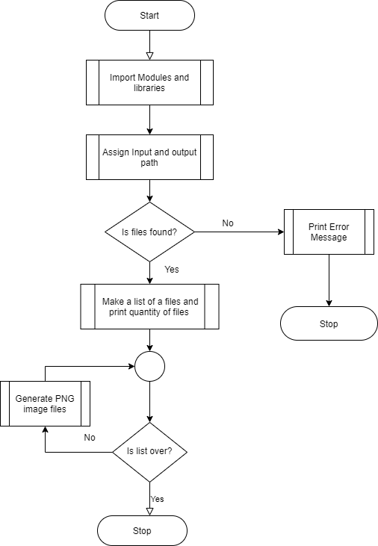

2.1.2 Python Script

import os
from matplotlib import pyplot as plt
import numpy
import pylab
import radiospectra
from radiospectra.sources.callisto import CallistoSpectrogram
import matplotlib.image as mpimg

os.system('ls')
os.system('pwd')
pathn= 'D:\CallistoData\Data\Today\\'
outpathn='D:\CallistoData\DataImg\\'
listed=os.listdir(pathn)
listed=numpy.sort(listed)
print (listed)
sized=len(listed)
print (sized)
for index in range(len(listed)):
filename=pathn+listed[index]
print (filename)
fig = plt.figure()
image = CallistoSpectrogram.read(filename)
image_c=image.clip_freq(45,870)
nobg = image_c.subtract_bg()
outfilename=outpathn+filen[0:25]+'.png'
print (outfilename)
fig.savefig(outfilename)
plt.close()

- Results

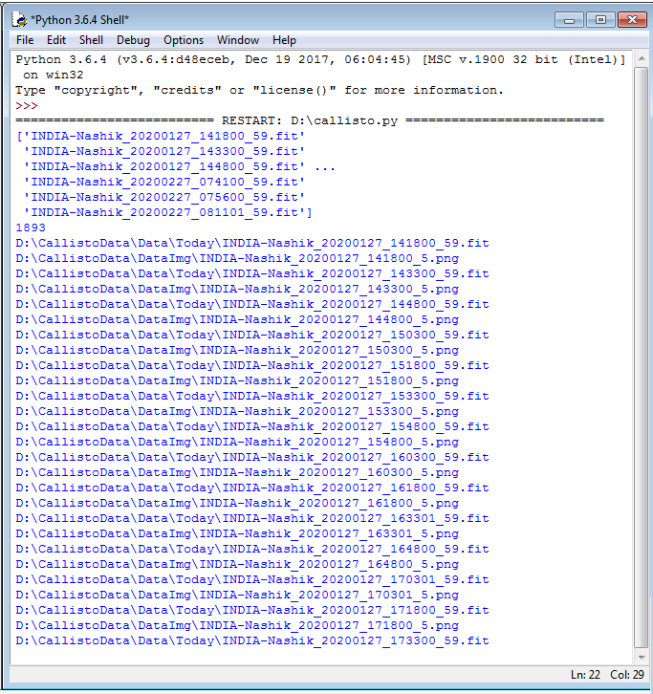
Figure 4. Output of python script

Above figure 4 shows that python script runs without any error.

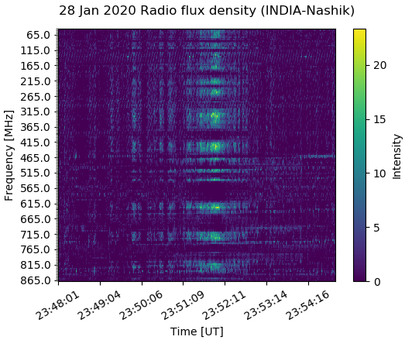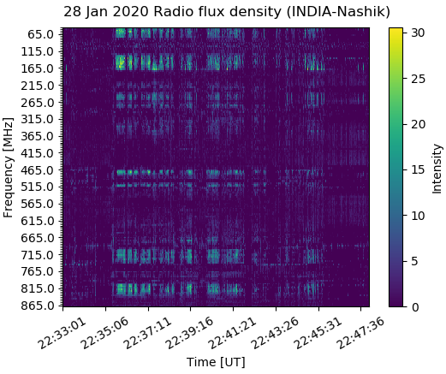

Figure 5. python output of PNG type images

Figure 5 shows the images generated by python script from FITs files stored at the input path location.

- Conclusion
Python is simple yet very powerful language. Script can be written in any text editing software and can have very simple format. The advantages of python script using for the image processing is that large number of files can be processed very fast. Only few sentences are used in script for image processing. The amount of background subtraction can be changed in script. Apart from advantages there are some disadvantages of the script and python software. It is very difficult to install and maintain the modules in python. Also, same file size is required for script to be run. Change in calculated files size stop the script with error.
  - Future Scope
Otherwise script can be written and adjusted such that it can be run automatically for newly generated files. Also, it can be modified to neglect the corrupted and inappropriate file size.

Acknowledgement

This research is supported by the Principal Dr. V. B. Gaikwad and prof Dhemse sir, Head, Department of Electronic Science, V S Kale, research guide and Principal, Arts and Commerce College, Makhamalabad, Nashik, Maharashtra, India-422003, Principal Dr. C. G Dighavkar and Dr. A. Patil, Head of Department, LVH College Panchavati, Nashik, Maharashtra, India. I am thankful of Mr. C. Monstain, Zurich University, Switzerland for his help related to e-CALLISTO and Network.

Reference

- L. J. Gray, J. Beer, M. Geller, J. D. Haigh, M. Lockwood, K. Matthes, U. Cubasch, D.Fleitmann, G. Harrison, L. Hood, J. Luterbacher, G. A. Meehl, D. Shindell, B. van Geel, and W. White, “Solar Influences on Climate”, Reviews of Geophysics,48: 1-53, 2010
- W. Orchiston, “The New Astronomy: Opening the Electromagnetic Window and Expanding our View of Planet Earth”, Springer, 191-202, 2005.
- A. O. Benz, C. Monstein, H. Meyer, P. K. Manoharan, R. Ramesh, A. Altyntsev, A. Lara, J. Paez, K. S. Cho, “A World-Wide Net of Solar Radio Spectrometers: e-CALLISTO”, Earth Moon and Planets, 104:277-285, 2009
- Dnyandev B. Patil, Vijay S. Kale, “A Review on Solar Radio Burst and Its Identification”, Journal of Emerging Technologies and Innovative Research (JETIR), Volume 6, Issue 6, 229-234, June 2019
- http://www.e-callisto.org/
- Duane H. D. Roller, “The De Magnete of William Gilbert”, Amsterdam: Menno Hertzberger, 1959
- Grigis, P. C., & Benz, A. O. “Spectral hardening in large solar flares”. The Astrophysical Journal, 683(2), 1180. 2008
- https://science.nasa.gov/science-news/science-at-nasa/2008/06may_carringtonflare
- Alex Soojung-Kim Pang, “Sun spotting”, American Scientist, 95, 538-540, 2007.

