Effect of various types of Dyes and N-doping in supporting performance of TiO₂ based Dye Sensitized Solar Cells

Shivam Yadav¹, Vinita Dhulia¹

¹N.E.S Ratnam College of Arts Science and Commerce, Mumbai, Maharashtra, India.
Corresponding Author: shivam.yadav@ratnamcollege.edu.in

Abstract
Dye Sensitised Solar Cell (DSSC) have piqued both practical and theoretical attention since they emerged as low-cost alternative to conventional silicon based solar cell[1][2]. TiO₂ nanoparticles are abundant, stable, and nontoxic and they are widely employed for a variety of applications[3]. The band gap of TiO₂ is determined to be about 3.2 eV for the anatase phase, which restricts the visible light absorption. Here we have analysed the absorption spectra for the pure TiO₂ and compared it with that of N-doped TiO₂ using a UV-visible spectrophotometer. Absorption spectra were also observed for composites of TiO₂ made by varying the concentration of Nitrogen[7]. Synthesis of TiO₂ and N-doped TiO₂ was done using Sol-gel method [4][5][6]. Particle size for TiO₂ was confirmed using X-Ray Diffraction.
It was observed that Nitrogen doping reduces the band gap leading to increase in the absorption of light in visible range. Further studies were carried out by adding four different Azo dyes as a sensitizer for N-doped TiO₂. I-V Characterisation of the samples was examined to determine their effectiveness. The best result was found with Methylene Blue.

Keywords: Dye Sensitised Solar Cell (DSSC), Azo Dye, TiO₂ Nano-particles, N-doped TiO₂, Energy band gap.

- Introduction
O’Regan and Grätzel reported that the Dye-Synthesized Solar Cell (DSSC) is a promising alternative to silicon and multi-junction solar cells[8]. DSSC is a device that converts photons into electrons[1][9]. The Dye used as a photosensitizer has a significant impact on the DSSC's performance[10]. This is because it absorbs more light than TiO₂ alone and converts photons to electrons, resulting in a higher photon to electron conversion efficiency[7].
The advantages of Azo dyes include their availability and low cost. For a dye to efficiently convert light to electricity in DSSC, the Lowest Unoccupied Molecular Orbital (LUMO) must have a more negative potential than TiO₂’s conduction band edge, allowing the injection process to be thermodynamically favourable. Furthermore, the dye must be in a good electrical and chemical contact with TiO₂ for electron injection to be efficient. The Highest Occupied Molecular Orbital (HOMO) of the dye must be more positive. Finally, the band gap of the dye must be as small as possible[2][11][12].

- Experimental Work

2.1 Synthesis of TiO₂ and Nitrogen doped TiO₂ Nanoparticles by Sol-Gel method

By using the Sol-Gel method, we have prepared samples of TiO₂ nanoparticles, pure TiO₂ and Nitrogen doped TiO₂[4][6][13]. Four different Azo dyes were obtained from Loba Chemicals: Methyl Orange, Methylene Blue, Eriochrome Black T and Alizarin Red. Titanium butoxide (C₁₆H₃₆O₄Ti) precursor used for TiO₂ nanoparticles synthesis, Ethanol (C₂H₅OH), De-ionized water, and Nitric acid (HNO₃) are taken in the ratio 1/20/0.5/0.1 respectively [13]. It was maintained at 450ºC for annealing. N-doped TiO₂ is obtained using TiO₂ nanoparticles and Tri-ethylamine (Nitrogen source) taken in equal ratios. Composites were also prepared with TiO₂ and 4 different Azo dyes taken in a ratio of 1:1 and also N-doped TiO₂ with Azo dyes taken in a ratio of 1:1.

2.2 Characterization of the Composites

2.2.1 Size of the TiO₂ Nanoparticles using XRD
X-Ray Powder Diffraction (XRD) patterns for the pure TiO₂ sample were collected and the crystal size of samples was calculated from peak broadening by the Scherrer equation.

2.2.2 Absorption Spectra of the composites
The absorption Spectra was studied using UV visible spectrophotometer first with pure TiO₂ and N-doped TiO₂, composites of TiO₂ with all four dyes taken in the ratio of 1:1, composites of N-Doped TiO₂ with all four dyes taken in ratio 1:1.

3 Results and Discussion
3.1 X-Ray Diffraction (XRD)
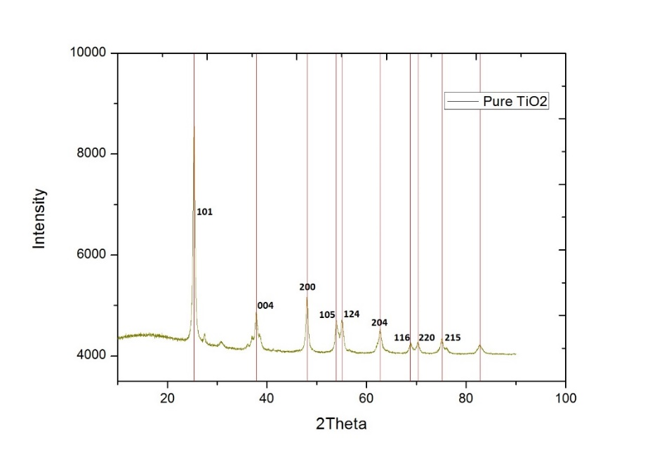
Figure1: XRD of Pure TiO₂
Figure 1 shows the X-Ray Diffraction pattern of Pure TiO₂. Diffraction peaks of Pure TiO₂ were obtained at 25.320, 37.870, 48.0560, 53.910, 55.080, 62.70, 68.760, 70.310, and 75.120. These can be assigned to crystal planes (101), (004), (200), (105), (211), (204), (116), (220) and (215) that correspond to the anatase phase of titania and agree with JCPDS card np.21-1272.
The average crystalline particle size is calculated by applying Sherer expressions in equation (1)
$$D=\frac{0.9 λ}{β.COSϴ}----(1)$$

Table 1 The average particle size of the sample
Sample | 2θ | FWHM  (Full Width Half Maxima) | Average particle size(nm)
Pure TiO₂ | 25.302 | 0.6177 | 13

The λ is X-Ray wavelength of 1.5406 Å of Cu kα radiation. β is the line broadening at maximum intensity (FWHM) and θ is the Bragg angle. The particle size is recorded in the table.

3.2 UV-Visible Spectroscopy

The Optical measurement was made using UV-VIS Spectrophotometer for the dyes and the composites of dyes with Pure TiO₂ and N-doped TiO₂ for the mixing ratio (1:1). The absorption Spectra showed the presence of distinct absorption peaks in the visible region for each type of dye.

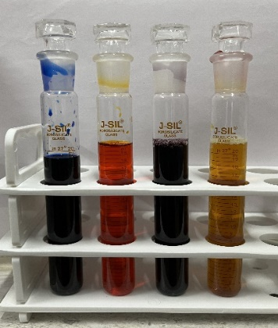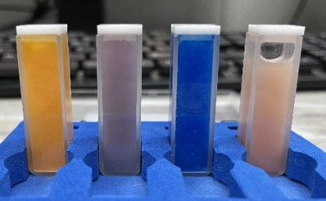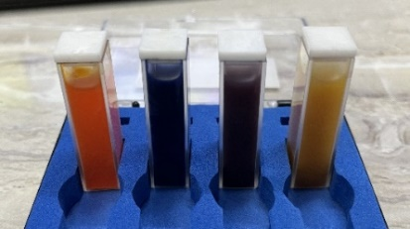
Image1: Azo Dyes At 1000 PPM Image2: Dyes with Pure TiO₂ Image3: Dyes with N-Doped TiO₂

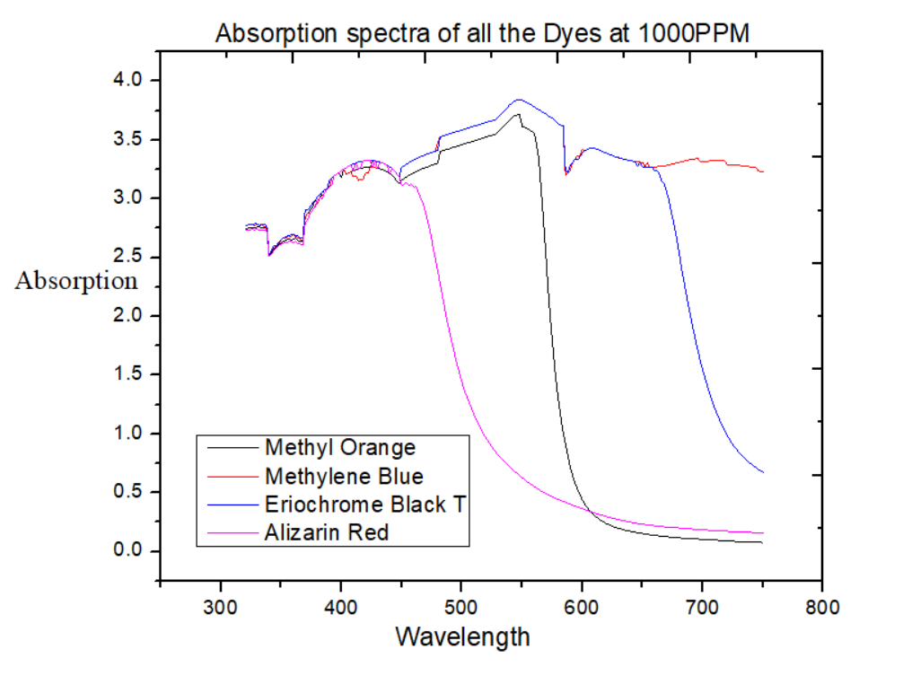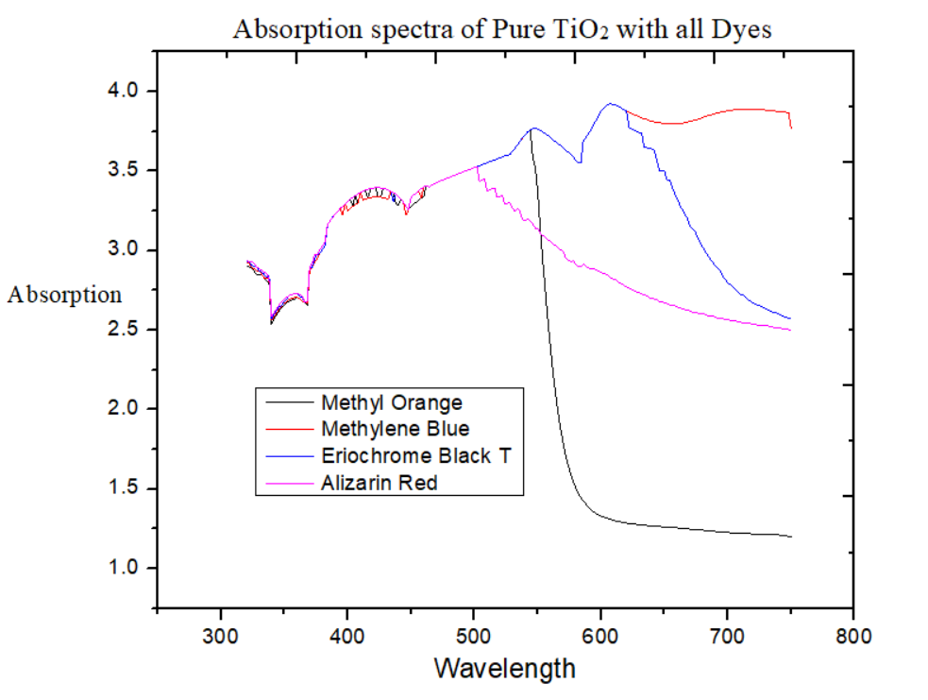
Figure2: Absorption Specta of all the 4 dyes Figure3: Absorption Spectra of Pure TiO₂ with all 4
dyes (1:1 Ratio)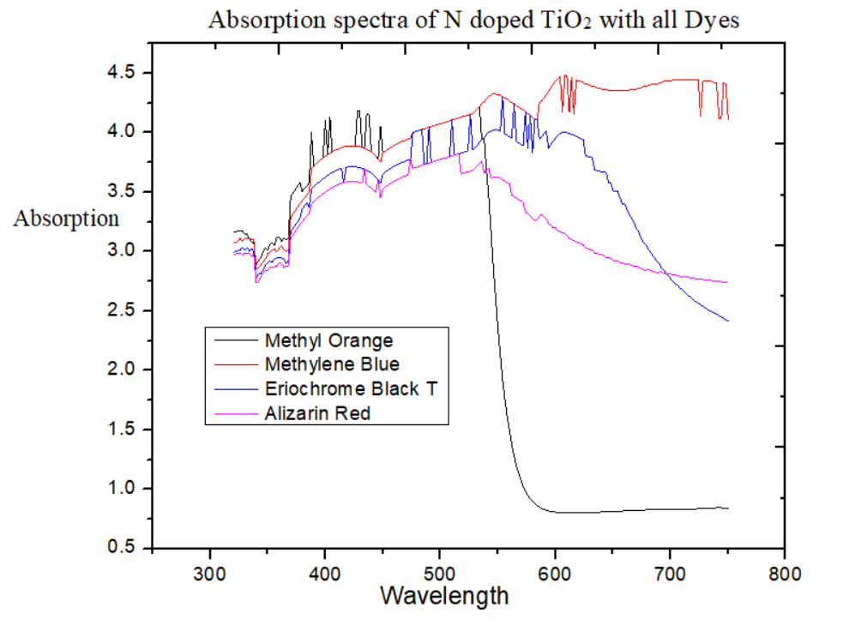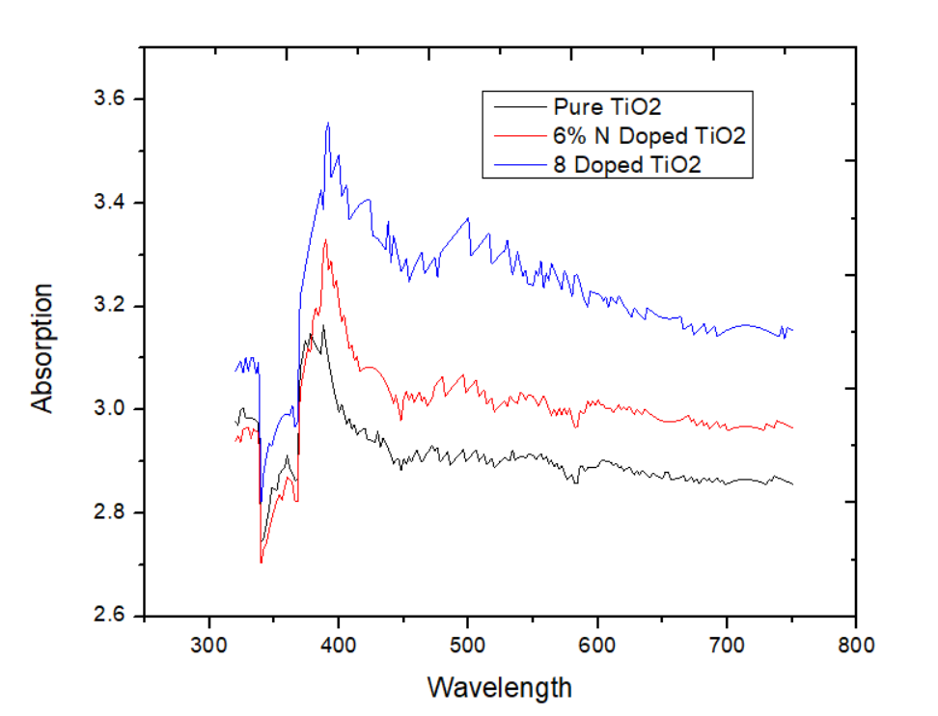
Figure4: Absorption Spectra of N-doped TiO₂ with Figure5: Absorption Spectra of Pure TiO₂
all 4 dyes (1:1 Ratio) and N-doped TiO₂

It is evident from the characterization that as nitrogen is introduced, the absorbance edge shifts, resulting in a smaller band gap. As a result, the N-doped TiO₂ sample had a greater absorption of visible light. Similarly, narrowing the band gap of TiO₂ leads to less charge recombination as compared to pure TiO₂.
Using the Kubelka-Munk formula[14] from equation (2), UV-Visible Spectra are transformed into Tauc plots to determine the band gap of the doped sample.
$$αhv=A{(hv-E_{g})}^{2}----(2)$$

where α is absorbance coefficient, h is the Plank’s constant (4.136*10⁻¹⁵eV), A is constant (̴1), $v$is frequency and E_{g} is band gap.

3.3 Band Gap
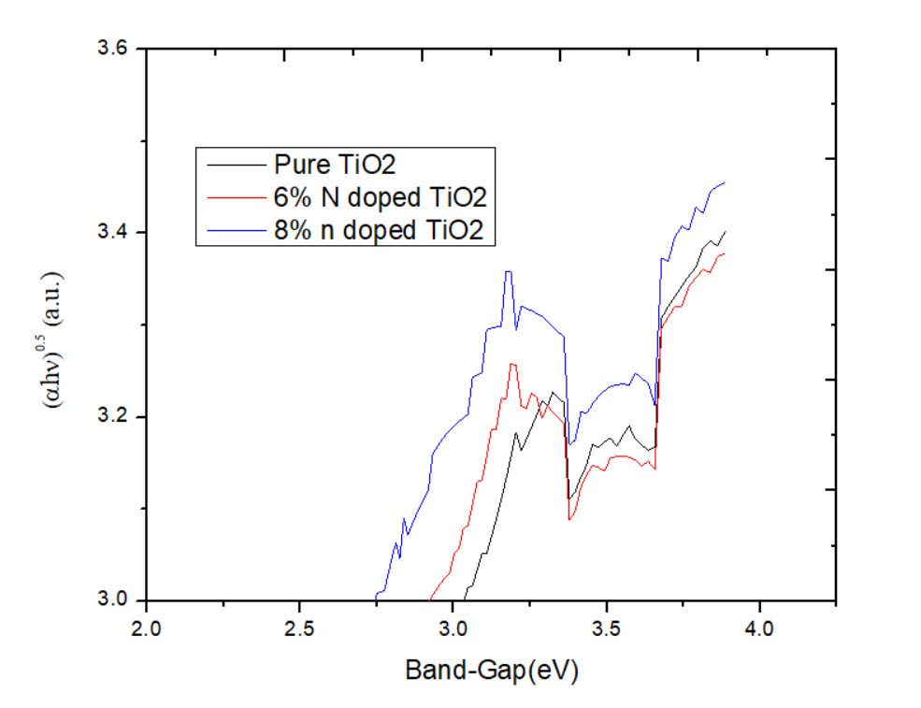

Figure 6: Band-Gap of Pure and N-doped TiO₂
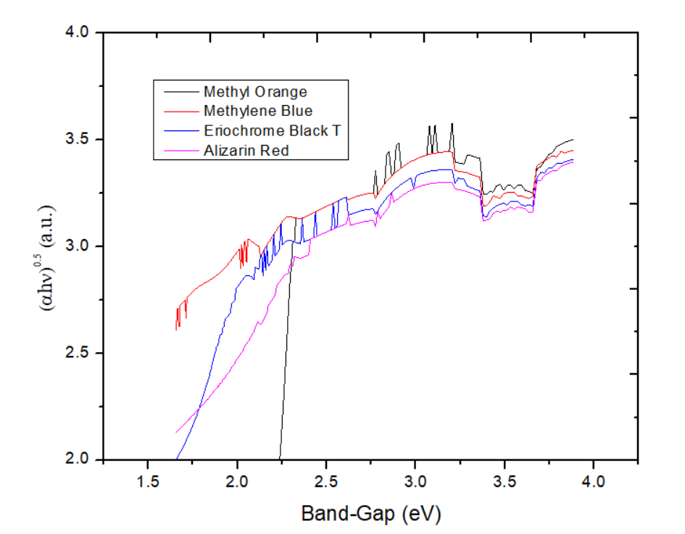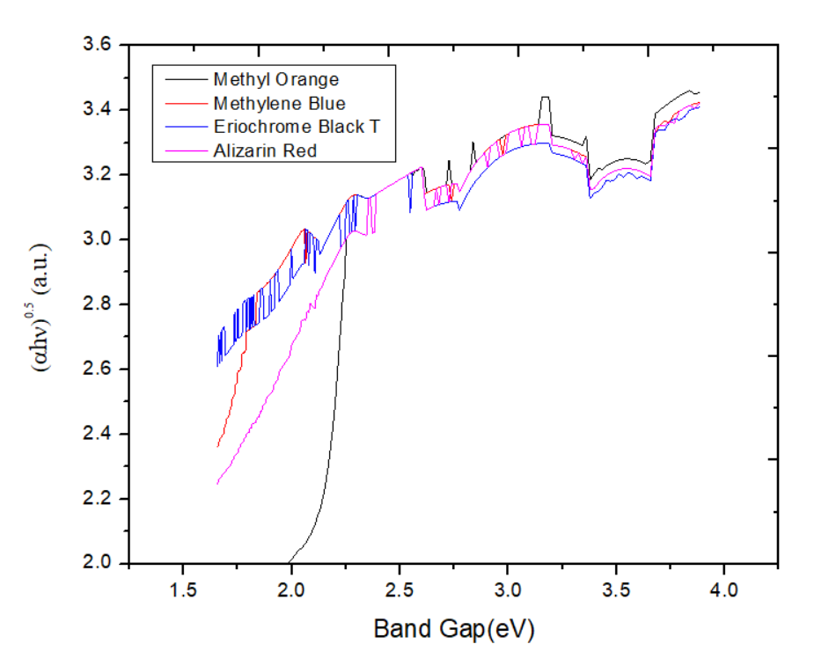
Figure7: Bandgap of Pure TiO₂ with all 4 Dyes Figure8: Bandgap of 8% N-doped TiO₂ with all 4 Dyes

Table 2 Bandgap energy for all samples
Sample | Band Gap (eV)
Pure TiO₂ | 3.05
6% doped TiO₂ | 2.92
8% doped TiO₂ | 2.73
8% doped TiO₂ with Methylene Blue | 1.63

Figure 6 shows the narrowing of the band-gap for N-doped TiO₂. Figure 7 and 8 show that TiO₂ with all the four dyes has enhanced absorption in visible region and narrowed band-gap maximum absorption was observed for Methylene Blue.

4 Conclusion

By examining the optical characteristics, it is observed that composites of dye with pure TiO₂ and N-doped TiO₂ enhance the performance of DSSC. Doping of TiO₂ with Nitrogen lowered its band gap. The composite of N-doped TiO₂ with Methylene Blue was found to have maximum absorption.

Acknowledgement

We are thankful to N.E.S. Ratnam College for providing laboratory facilities, we would also like to thank department of Chemistry for providing the essential chemicals, Sophisticated Analytical Instrument Facility (SAIF) IIT Bombay for providing UV-Vis Spectrometer data and Doctor Nainesh Patel for providing XRD data.

References
- Ahmad, Muhammad Shakeel, Adarsh Kumar Pandey, and Nasrudin Abd Rahim. "Advancements in the development of TiO₂ photoanodes and its fabrication methods for Dye Sensitized Solar Cell (DSSC) applications. A review." Renewable and Sustainable Energy Reviews 77 :89-108. (2017)
- Reghunath, Shalini, Dephan Pinheiro, and Sunaja Devi KR. "A review of hierarchical nanostructures of TiO₂: Advances and applications." Applied Surface Science Advances 3 :100063. (2021)
- Dahl, Michael, Yiding Liu, and Yadong Yin. "Composite Titanium dioxide nanomaterials." Chemical reviews 114.19 :9853-9889. (2014)
- Bessekhouad, Y., D. Robert, and J. V. Weber. "Preparation of TiO₂ nanoparticles by Sol-Gel route." International journal of photoenergy 5.3: 153-158. (2003)
- Sharma, Ajay, R. K. Karn, and S. K. Pandiyan. "Synthesis of TiO₂ nanoparticles by sol gel method and their characterization." J Basic Appl Eng Res 1.9: 1-5. (2014)
- Sathish, M., et al. "Synthesis, characterization, electronic structure, and photocatalytic activity of Nitrogen-doped TiO₂ nanocatalyst." Chemistry of materials 17.25: 6349-6353. (2005)
- Cong, Ye, et al. "Synthesis and characterization of Nitrogen-doped TiO₂ nanophotocatalyst with high visible light activity." The Journal of Physical Chemistry C 111.19: 6976-6982. (2007)
- O'regan, Brian, and Michael Grätzel. "A low-cost, high-efficiency solar cell based on dye-sensitized colloidal TiO₂ films." nature 353.6346 (1991): 737-740.
- Suhaimi, Suriati, et al. "Materials for enhanced dye-sensitized solar cell performance: Electrochemical application." Int. J. Electrochem. Sci 10.4 (2015): 2859-2871.
- Ludin, Norasikin A., et al. "Review on the development of natural dye photosensitizer for dye-sensitized solar cells." Renewable and Sustainable Energy Reviews 31 (2014): 386-396.
- Shalini, Status, et al. "Status and outlook of sensitizers/dyes used in dye sensitized solar cells (DSSC): a review." International journal of energy research 40.10 (2016): 1303-1320.
- Shalini, Status, et al. "Status and outlook of sensitizers/dyes used in dye sensitized solar cells (DSSC): a review." International journal of energy research 40.10 (2016): 1303-1320.
- Fernandes, R., et al. "Low energy ion-beam modification of TiO₂ photocatalyst thin film for visible light absorption." Surface and Coatings Technology 203.17-18 (2009): 2579-2583.
- Yang, Li, and Björn Kruse. "Revised Kubelka–Munk theory. I. Theory and application." JOSA A 21.10 (2004): 1933-1941.

