SYNTHESIS, CHARACTERIZATION AND ANTIMICROBIAL ACTIVITY OF PURE AND HYBRID SBA-15 NANOPARTICLES DOPED WITH [Tb (NO ₃) ₃(H ₂O)₄]·2H₂O]
Dypsy Khapra¹, Ravi Rana¹, Vijay kiran², Aarti Ahlawat³
¹Department of Chemistry, Baba Masthnath University, Rohtak, Haryana - 124001, India
²Department of Chemistry, C.R.A College Sonipat, Haryana -131001, India
³Department of Chemistry, PDM University, Bahadurgarh, Haryana - 124507, India
*Corresponding Email ID: dipsikhapra@gmail.com
_________________________________________________________________________________
Abstract
Pure SBA-15(Santa Barbara Amorphous-15) nanoparticles have been synthesized by Hydrothermal process using TEOS (Tetraethyl orthosilicate), pluronic P123.Furthermore, the hybrid SBA-15has been synthesized using TEOS (Tetraethyl orthosilicate), pluronic P123 and Terbium(III) nitrate hexahydrate [Tb(NO 3) 3(H 2O) 4]·2H2O].The synthesized nanoparticles were characterised by various spectroscopic techniques (XRD) X-ray diffraction, (FTIR) Fourier transform infrared spectroscopy, and (TEM) transmission electron microscopy. The results of this study demonstrate that doping such as Tb+3, into SBA-15 significantly improved the surface area and porosity of the nanoparticles. Moreover, the increased surface area and porosity of the doped nanoparticles improved their adsorption capacity. Furthermore, the synthesized compounds were evaluated for antibacterial and antifungal activities against Staphylococcus aureus (NCIM 2901), Escherichia coli (MTCC 732) and Aspergillus niger (MTCC 9933). The doped hybrid nanoparticles were found to be more active than the pure SBA-15.
Keywords: SBA-15, Hydrothemal treatment, Antimicrobial Activity

Introduction
Nanoparticle-based materials absorb solar energy in solar cells more effectively than thin films formed of materials [1-3]. Additionally, these nanoparticles can be used for renewable energy storage [4]. Because of their small size, titanium dioxide nonporous particles have a microscopic ability to self-clean [5], and the resulting hydrophilicity increases the efficiency of solar cells and their photo stability [6]. Mesoporous nanoparticles are particles having a diameter between 10 nm and 100 nm. Nanoparticles are solid materials with pores ranging in size from 1 nm to 100 nm that allow organic and inorganic compounds to be adsorbed or dissolved [7]. The link between bulk materials and atomic structures is formed by nanoparticles, which provide a variety of properties that differ from those of bulk materials. Since the physical characteristics of bulk materials are usually size dependent, these characteristics cannot be changed by varying temperature, pressure, or acidity [8]. However, size dependent characteristics are observed at the nanoscale; without affecting the material’s chemical characteristics, it is possible to change a material's physical characteristics, such as its boiling point, melting point, and magnetic properties. Utilizing this ability, we can now synthesise different products that were previously impossible [9]. Today, different metal or non-metal doped nanostructures are synthesised using copper, zinc, titanium, magnesium, gold, and silver [10]. This phenomenon has made way for a whole new era of nanostructured materials that have opened the doors to new and innovative applications in fields such as medicine, energy storage, catalysis, optoelectronics, and even the food industry Tetraethyl orthosilicate is used to synthesise mesoporous silica nanoparticles. An extra polymer monomer is employed with tetraethyl orthosilicate [14]. The use of this precursor decreases aggregation and ensures a more uniform sphere. Mesoporous silica nanoparticles have a high pore volume, a large pore size, and a greater surface area [15]. There are three different kinds of MSN particles (a) ordered mesoporous nanoparticles (b) Hollow or rattle-type mesoporous nanoparticles(c)mesoporous nanoparticles with a core-shell structure [16]. Ordered mesoporous nanoparticles are uniformly distributed and have a uniform pore size. They are arranged logically [17]. Due to their appealing features and potential for detecting air pollution produced by VOCs, hybrid mesoporous nanoparticles have developed a lot of interest [18]. Because of their appealing properties such as uniform distribution and pore size, as well as their potential for detecting air pollution caused by volatile organic compounds (VOCs), hybrid mesoporous nanoparticles have sparked a lot of interest. Nanomaterial research has gotten a lot of attention in the last several decades. Some examples of mesoporous compounds are SBA-15 and MCM-41. SBA-15 is a two-dimensional array of hexagonal pores with long one-dimensional channels. This nanostructure offers a unique combination of features, such as an exceptionally large internal surface area and regular pore structure, that are highly beneficial for a wide range of applications. Silica nanoparticles (SNs) with an improved strategy that exhibit controlled size, high biocompatibility, biodegradability, and stability under physiological circumstances constitute interesting platforms for biological application [20]. Recent studies have suggested that SBA-15 nanoparticles provide a much more versatile platform than MCM41. Biological synthesis uses the metabolic pathways of living organisms to create nanoparticles that can be used in medical treatments, such as gene delivery and drug delivery. Co-precipitation has been used to create nanomaterials for electronics, catalysts, and other industrial applications [21]. All of these methods have been used to synthesise nanoparticles for various applications, from biomedical treatments to materials science and industrial uses [22]. Hydrothermal synthesis has been used to synthesise carbon nanotubes, quantum dots, and other nanostructures. Furthermore, they have possessed various antibacterial and antifungal properties.
2. Experimental Work
2.1Materials and methods:
All the chemicals used TEOS(Tetraethylorthosilicate), pluronicp₁₂₃ (EO₂₀PO₇₀EO₂₀), Terbium(III) nitrate hexahydrate [Tb (NO ₃) ₃(H ₂O) ₄] ·2H₂O] were purchased from Sigma-Aldrich. The solvents used (hydrochloric acid and distilled water) were of analytical grade.
2.2 instrumentation:The structural morphologies of the synthesised samples were investigated using powder X-ray diffraction plots, which were recorded using X-Ray Diffractometer (Rigaku Ultima –IV). The mesoporous framework of the sample and pores structure were examined using TEM and Tests were conducted on a Talos (Thermo Fisher scientific) electron microscope operating at 200kv. FT-IR spectra was taken using a FTIR ( Perkin-Elmer 580 B ) in the 4000–400 cm⁻¹ range.
2.3 Procedure
2.3.1 Synthesis of pure mesoporous SBA-15 [A]
The pure mesoporous SBA-15 has been synthesized by the following method: P₁₂₃ was first stirred in 65 ml of distilled water at 40 °C and agitated for 30 minutes to obtain the product. It was continuously stirred to dissolve the resulting solution in hydrochloric acid at 40 °C. After obtaining a clear, transparent solution, 4.6 ml of TEOS was added. The mixture was kept at 40 °C with continuous stirring for two hours. The mixture was then cooled to room temperature and poured into a beaker. After acquiring the solid product, it was filtered, washed with distilled water and ethanol, and dried. The hydrothermal treatment was completed in an autoclave for 24 hours at 108 °C. Afterwards, the product was removed from the autoclave, cooled to room temperature, and centrifuged 3–4 times at 500 rpm with distilled water. The solid material was collected by filtration, washed again with distilled water and ethanol, and dried in an oven at 80 °C overnight. The product was calcined for 4 hours at 500 °C inside a furnace, yielding the SBA-15. The scheme for the synthesis of the compound A is represented in scheme 1.
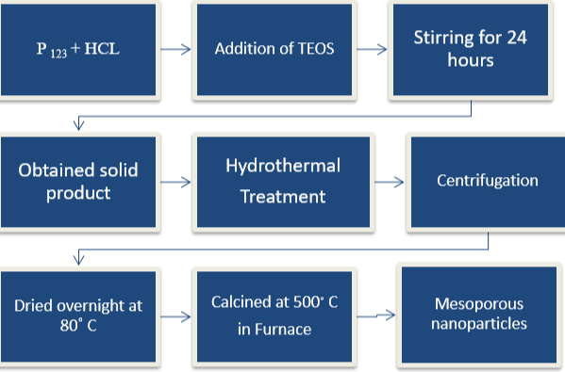
Scheme 1. Schematic representation of synthesis of Mesoporous nanoparticles
2.3.2 Synthesis of SBA-15 doped with 5% Tb [B]
The synthesis of 5% Tb⁺³-doped silica nanoparticles (SNs) was performed by the hydrothermal method. P₁₂₃ was first stirred in 65 ml of distilled water at 40 °C and agitated for 30 minutes to obtain the product. Continuous stirring was used to dissolve the resulting solution in hydrochloric acid at 40 °C. After obtaining a clear solution of 0.085 g of Tb (NO₃), 5 H₂O was added to the clear solution, and then TEOS was added dropwise as a silica source. The mixture was then cooled to room temperature and poured into a beaker. After acquiring the solid product, it was filtered, washed with distilled water and ethanol, and dried. The hydrothermal treatment was completed in an autoclave for 24 hours at 108 °C. After the autoclave treatment, the resulting product was cooled to room temperature. The solid material was collected and centrifuged 3–4 times at 500 rpm with distilled water. The solid product was then dried in the oven overnight at 80 °C. The product was calcined for 4 hours at 500 °C inside a furnace. SBA-15 doped with 5% Tb⁺³ was obtained.
2.3.3 Synthesis of SBA -15 doped with 10%Tb [C]
The hydrothermal method was used to create silica nanoparticles that are 10% Tb⁺³ doped. P₁₂₃ was initially solubilized in 65 ml of distilled water at 40 °C and stirred for 30 minutes to produce the result. The resultant solution was dissolved in hydrochloric acid with constant stirring. After this, 0.17 g of Tb was added to the solutions. After 30 minutes of stirring, TEOS was added to the solutions. Then the solution was put on a magnetic stirrer for 24 hours. The stirring caused a chemical reaction between the Tb and TEOS, which resulted in the formation of nanocrystals After acquiring the solid product, a 24-hour hydrothermal treatment was completed at 108 °C in an autoclave. The hydrothermal treatment altered the size, shape, and morphology of nanocrystals and helped with crystallisation. The solid product was then filtered and washed to remove the uncrystallised Tb-TEOS precursors. The solid material was collected and centrifuged 3–4 times at 500 rpm with distilled water.
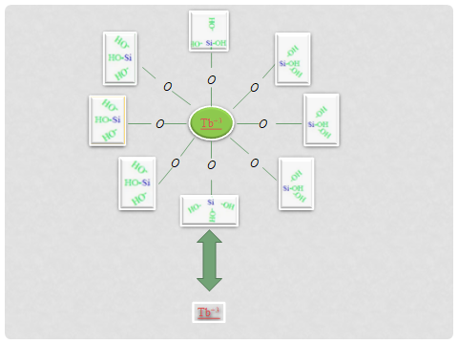
Figure 1: Hybrid Mesoporous nanoparticles (Tb SBA-15)
The solid product was then dried in the oven overnight at 80 °C. After the solid product had been collected, it was centrifuged at 500 rpm with distilled water three to four times to remove any impurities. The solids were calcined at 500 °C for 4 hours to produce the Tb⁺³ doped nanoparticles. The hybrid mesoporous compound formed and the silica mesoporous nanoparticles formed are shown in figure 1 and figure 2 respectively.
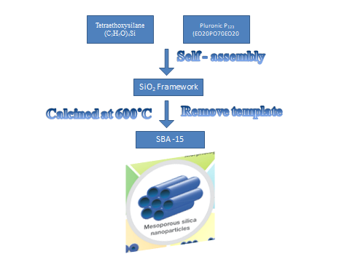
Figure 2: Formation of Silica Mesoporous nanoparticles

2.4 In Vitro Antimicrobial Activity
The samples prepared were screened for in vitro antimicrobial activity using serial dilution method against bacterial and fungal strains for evaluating the minimum inhibitory concentration. Nutrient broth and Sabouraud dextrose broth were applied as growth mediums for the bacteria and fungi, respectively. The nutrient medium was placed in test tubes containing 1 ml of nutrients that were autoclaved for 30 minutes at 121 °C. Stock solutions of the test compound at a concentration of 100 g/ml were prepared in DMSO. A set of six dilutions of the compounds with concentrations of 50, 25, 12.5, 6.25, 3.12, and 1.56 g/ml were prepared by serial dilution the of the compound (1 ml) in test tubes with sterile nutrient growth. Each test tube received 100 μg/mL of freshly cultured strain in normal saline, which was then added for inoculation. The test tubes were then incubated at 37 °C for 24 hours for bacterial strains and at 25 °C for 7 days for fungal strains. After the incubation period, the test tubes were examined for their growth, and the minimum inhibitory concentrations (MICs) were recorded. ciprofloxacin and Fluconazole were used as standard drugs for analysing antibacterial and antifungal activity, respectively. After the MICs were recorded, the antibacterial and antifungal activity of the compounds were compared to those of the standard drugs. The compounds were tested three times, and the concordant MIC values were calculated.
3. Results and Discussions
3.1 X- ray diffraction
The structure and morphology of SBA-15 have been examined using XRD. X-ray diffraction (XRD). Four diffraction peaks (100), (110), (200), and (210) appear in the spectrum. These peaks indicate the presence of crystalline silica and correspond to the (100), (110), (200), and (210) planes of the SBA-15 structure. The peak positions and intensities of these peaks indicate a highly crystalline and well-ordered SBA-15 mesostructure with uniform pore size [23]. The peaks determine the hexagonal structure of the prepared compounds. The XRD pattern of the synthesized compounds is shown in figure 3.

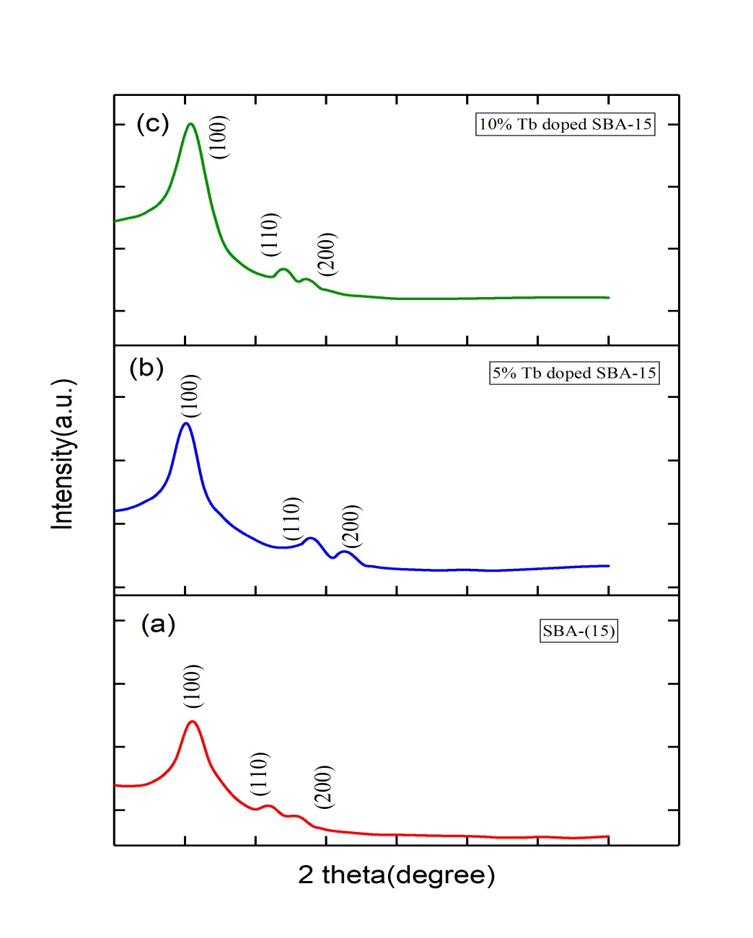
Figure 3: XRD pattern of compounds A-C
3.2 Fourier Transform Infrared
The synthesized compounds were also characterized by FT-IR technique. The broad band between 3020 cm⁻¹ and 3730 cm⁻¹ is due to the existence of OH and Si-OH groups on the surface of the nanoparticles. This demonstrates that the presence of such hydroxyl groups can lead to significant structural and optical modifications in the nanoparticles. The strong infrared absorption band around 1080 cm⁻¹ is due to the (Si-O-Si) stretching vibration. This band is generally attributed to the stretching vibration of the Si-O-Si bond in silica and is strong evidence for the presence of surface hydroxyl groups on nanoparticles [24]. The characteristic bands around 1370–1620 cm⁻¹ are due to bending vibrations of the OH (hydroxyl group), and the bending vibrations can occur either in the same plane or out of plane. The intense, sharp bands around 474 cm⁻¹ are unique to this group of compounds and provide evidence of the presence of the Tb-O-Si linkages. The FTIR spectra is given in figure 4. These results could be very important for the productivity of biomaterials in biological systems as well as for their high chemical stability under different conditions. The presence of these linkages provides additional evidence that biomaterials with Tb-O-Si linkages are stable under different conditions, can offer superior properties compared to materials without doping, and indicates increased molecular stability and resistance to degradation. These results indicate that silica had been successfully coated on the surfaces of terbium nitrates.
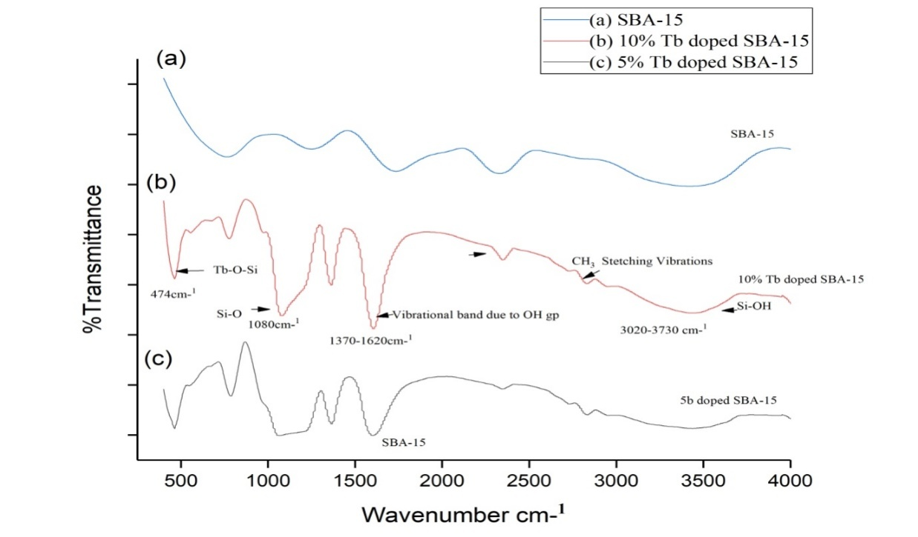
Figure 4: FTIR spectra of compounds A-C
3.3 TEM Analysis
Transmission electronic micrographs were used to study the pore geometry of the nanoparticles. The samples were spread out in ethanol and deposited on Carbon coated copper grids. The results of the TEM experiments were used to confirm the differences in structure and microstructure between the materials. The highly porous and hollow structure is visible in Figure 5(b) which depicts hexagonal nanoparticle arrangements. Figure 5(c) demonstrates that the fabrication method used was successful in producing this unique structure. The TEM images of the samples demonstrated that the samples have unique features, such as highly porous and hollow structures, as well as hexagonal arrangements of nanoparticles.
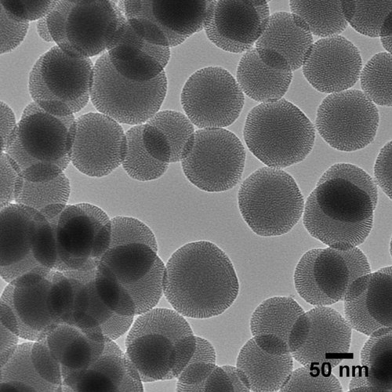
Figure 5(a): TEM images of Mesoporous SBA-15

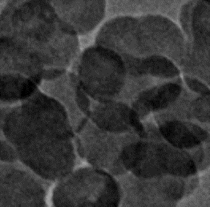
Figure 5 (b): Hexagonal arrangement of particles
Figure 5 (c): Porous structure of the compound
The results of the TEM experiments indicated that both materials were composed of interconnected nanoparticles with different lattice constants According to TEM images (Figure 5d and 5e), the Tb⁺³ ions were detected inside the silica frameworks, interacting with the Si-O-Si linkages, which further confirmed the formation of the framework [25].
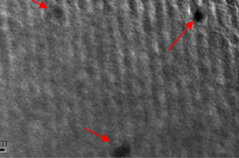
Figure 5d: SBA-15 with doped Tb
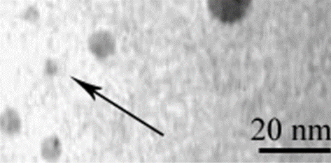
Figure 5e: Tb doped nanoparticles
3.4 Evaluation of Antimicrobial Activities
The synthesized compounds (A-C) were tested in vitro for biological activity against the bacteria S. Aureus, E. Coli, and the fungi A niger (antibacterial and antifungal properties). Ciprofloxacin and fluconazole were commonly used drugs for antibacterial and antifungal activity [26]. The serial dilution method was used to detect antimicrobial activity. The antimicrobial activity data are presented in Table 1 as MIC (minimum inhibitory concentration μm/ml).
Table 1: Antimicrobial activity of synthesized compounds (μm/ml)
Compound | pMICsa | pMICec | pMICan
A | 1.346 | 1.667 | 2.031
B | 1.735 | 1.812 | 2.131
C | 1.893 | 1.987 | 2.25
Std. | 2.61 | 2.61 | 2.64

It was clear from the data that compounds which are doped with tb+3 were significantly more active than pure SBA-15. The chelation theory states that chelation causes complexes to become more influencing, effective, and intoxicating because it tends to formulate ligands to function as more influential and better antimicrobial agents, which can explain why the antimicrobial activity of synthetic complexes has increased. It was seen that the compound C showed maximum activity against the bacterial and fungal strains. It was also concluded that Tb⁺³ doping increased the potency against fungal strains due to the chelation effect. This is due to the fact that the Tb⁺³ doping increases the effective binding ability of the complexes, allowing for more efficient chelation of the ligands to form a tighter bond, leading to increased antimicrobial activity [27].
4. Conclusions
Using a hydrothermal method, pure and hybrid sns with Tb⁺³ doped with 5% and 10% have been successfully synthesised and characterised using various analytical techniques such as transmission electron microscopy (TEM), X-ray diffraction (XRD), and Fourier transform infrared spectroscopy (FTIR). XRD results show that mesoporous pure SBA-15 nanoparticles and Tb doped nanoparticles have orderly hexagonal pore patterns. The XRD pattern showed an increase in the intensity of the peaks for Tb-doped SBA-15 nanoparticles compared to pure SBA-15 nanoparticles, indicating an increased crystallinity due to doping. The results of these analyses revealed that the Tb⁺³ doped nanoparticles showed a larger pore size compared to pure SBA-15. TEM images indicated that Tb doped nanoparticles were successfully synthesised by the hydrothermal method. TEM images of pure and doped nanoparticles showed their hexagonal shapes with uniform sizes. FTIR results also show that Tb⁺³ ions have been introduced to SBA-15. FTIR spectra showed the presence of silanol and hydroxyl groups on the surfaces of both pure and Tb-doped SBA-15 nanoparticles, confirming the successful synthesis. In addition, the average particle size of the Tb-doped SBA-15 nanoparticles was larger than that of pure SBA-15 nanoparticles, as revealed by transmission electron microscopy (TEM) analysis. Furthermore, the Tb⁺³ doped nanoparticles had greater thermal stability and a higher surface area than the pure SBA-15, indicating that the Tb⁺³ doped nanoparticles may have a more efficient adsorption capacity. These results suggest that the Tb⁺³ doped SBA-15 nanoparticles are well-suited for adsorption applications, such as water purification and wastewater treatment. In addition, the large particle size of the Tb-doped SBA-15 nanoparticles allows them to carry a larger amount of drug and, thus, have more efficient drug delivery than the pure SBA-15. This suggests that the Tb⁺³ doped SBA-15 nanoparticles could be used in multiple industries for a variety of purposes, including energy storage and conversion, water treatment, and environmental remediation. Additionally, the research indicates that the Tb⁺³ doped SBA-15 nanoparticles are capable of withstanding high temperatures and can therefore be used in a variety of processes requiring high temperatures. The compounds were found to be potent against various microbial strains.
Conflict of Interest
The authors declare that there is no conflict of interests regarding the publication of this article.
References
[1] e. A. Syukkalova et al., “the effect of reaction medium and hydrothermal synthesis conditions on morphological parameters and thermal behavior of calcium phosphate nanoparticles,” ceram. Int., vol. 47, no. 2, pp. 2809–2821, jan. 2021, doi: 10.1016/j.ceramint.2020.09.135.
[2] x. Y. Liu, j. Q. Wang, c. R. Ashby, l. Zeng, y. F. Fan, and z. S. Chen, “gold nanoparticles: synthesis, physiochemical properties and therapeutic applications in cancer,” drug discovery today, vol. 26, no. 5. Elsevier ltd, pp. 1284–1292, may 01, 2021. Doi: 10.1016/j.drudis.2021.01.030.
[3] p. G. Jamkhande, n. W. Ghule, a. H. Bamer, and m. G. Kalaskar, “metal nanoparticles synthesis: an overview on methods of preparation, advantages and disadvantages, and applications,” journal of drug delivery science and technology, vol. 53. Editions de sante, oct. 01, 2019. Doi: 10.1016/j.jddst.2019.101174.
[4] b. Khodashenas and h. R. Ghorbani, “synthesis of silver nanoparticles with different shapes,” arabian journal of chemistry, vol. 12, no. 8. Elsevier b.v., pp. 1823–1838, dec. 01, 2019. Doi: 10.1016/j.arabjc.2014.12.014.
[5] m. Arakha and s. Jha, “synthesis and characterization of nanoparticles,” 2018, pp. 37–59. Doi: 10.1007/978-3-319-73326-5_2.
[6] p. V. Suraja, z. Yaakob, n. N. Binitha, s. Triwahyono, and p. P. Silija, “co3o4 doped over sba 15: excellent adsorbent materials for the removal of methyleneblue dye pollutant,” clean technol. Environ. Policy, vol. 15, no. 6, pp. 967–975, 2013, doi: 10.1007/s10098-012-0558-2.
[7] y. Han, x. Wang, s. Li, and x. Ma, “synthesis of terbium doped calcium phosphate nanocrystalline powders by citric acid sol-gel combustion method,” j. Sol-gel sci. Technol., vol. 49, no. 1, pp. 125–129, 2009, doi: 10.1007/s10971-008-1832-y.
[8] z. Wang and y. Wang, “preparation and photocatalytic application of terbium and sulfur co- doped titanium nanomaterials,” pp. 1–10, 2022.
[9] s. Iravani, h. Korbekandi, s. V mirmohammadi, and b. Zolfaghari, “synthesis of silver nanoparticles: chemical, physiciravani, s., korbekandi, h., mirmohammadi, s. V, & zolfaghari, b. (2014). Synthesis of silver nanoparticles: chemical, physical and biological methods. Research in pharmaceutical sciences, 9(6), 385–406. ,” res. Pharm. Sci., vol. 9, no. 6, pp. 385–406, 2014, [online]. Available: http://www.ncbi.nlm.nih.gov/pubmed/26339255%0ahttp://www.pubmedcentral.nih.gov/articlerender.fcgi?artid=pmc4326978
[10] s. C. Kumari, v. Dhand, and p. N. Padma, “green synthesis of metallic nanoparticles: a review,” nanomaterials, pp. 259–281, 2021, doi: 10.1016/b978-0-12-822401-4.00022-2.
[11] h. Liu, k. Tao, p. Zhang, w. Xu, and s. Zhou, “enhanced catalytic performance for metathesis reactions over ordered tungsten and aluminum co-doped mesoporous kit-6 catalysts,” new j. Chem., vol. 39, no. 10, pp. 7971–7978, 2015, doi: 10.1039/c5nj01415h.
[12] q. Gao et al., “synthesis of zsm-5/kit-6 with a tunable pore structure and its catalytic application in the hydrodesulfurization of dibenzothiophene and diesel oil,” rsc adv., vol. 8, no. 51, pp. 28879–28890, 2018, doi: 10.1039/c8ra05675g.
[13] j. K. Shon et al., “facile synthesis of highly ordered mesoporous silver using cubic mesoporous silica template with controlled surface hydrophobicity,” 2009. Doi: 10.1039/b811718g.
[14] j. Fan et al., “nanocasting synthesis of mesoporous sno2 with a tunable ferromagnetic response through ni loading,” rsc adv., vol. 6, no. 106, pp. 104799–104807, 2016, doi: 10.1039/c6ra23918h.
[15] o. Mazaheri and r. J. Kalbasi, “preparation and characterization of ni/mzsm-5 zeolite with a hierarchical pore structure by using kit-6 as silica template: an efficient bi-functional catalyst for the reduction of nitro aromatic compounds,” rsc adv., vol. 5, no. 43, pp. 34398–34414, 2015, doi: 10.1039/c5ra02349a.
[16] a. Wawrzyńczak, s. Jarmolińska, and i. Nowak, “nanostructured kit-6 materials functionalized with sulfonic groups for catalytic purposes,” catal. Today, vol. 397–399, no. Xxxx, pp. 526–539, 2022, doi: 10.1016/j.cattod.2021.06.019.
[17] f. R. D. Fernandes, f. G. H. S. Pinto, e. L. F. Lima, l. D. Souza, v. P. S. Caldeira, and a. G. D. Santos, “influence of synthesis parameters in obtaining kit-6 mesoporous material,” appl. Sci., vol. 8, no. 5, 2018, doi: 10.3390/app8050725.
[18] m. Khabazipour, s. Shariati, and f. Safa, “sba and kit-6 mesoporous silica magnetite nanoparticles: synthesis and characterization,” synth. React. Inorganic, met. Nano-metal chem., vol. 46, no. 5, pp. 759–765, 2016, doi: 10.1080/15533174.2014.989583.
[19] j. C. Ahern, a. D. Nicholas, a. W. Kelly, b. Chan, r. D. Pike, and h. H. Patterson, “a terbium chlorobismuthate(iii) double salt: synthesis, structure, and photophysical properties,” inorganica chim. Acta, vol. 478, no. Iii, pp. 71–76, 2018, doi: 10.1016/j.ica.2018.03.040.
[20] m. B. M. De campos, m. A. Cebim, m. R. Meirelles, e. C. Paris, and a. H. Rosa, “influence of terbium (iii) ions on the photocatalytic activity of tio2 and ceo2 for the degradation of methylene blue in industrial effluents,” environ. Sci. Pollut. Res., vol. 28, no. 21, pp. 27147–27161, 2021, doi: 10.1007/s11356-021-12571-z.
[21] b. Zhou, c. Y. Li, n. Qi, m. Jiang, b. Wang, and z. Q. Chen, “pore structure of mesoporous silica (kit-6) synthesized at different temperatures using positron as a nondestructive probe,” appl. Surf. Sci., vol. 450, pp. 31–37, 2018, doi: 10.1016/j.apsusc.2018.03.223.
[22] m. A. Ballem, j. M. Córdoba, and m. Odén, “influence of synthesis temperature on morphology of sba-16 mesoporous materials with a three-dimensional pore system,” microporous mesoporous mater., vol. 129, no. 1–2, pp. 106–111, 2010, doi: 10.1016/j.micromeso.2009.09.004.
[23] s. Hazarika, d. Mohanta, and r. Nirmala, “physica b : condensed matter enhanced magnetocaloric e ff ect in terbium-doped gadolinium oxide nanoparticles,” phys. B phys. Condens. Matter, vol. 570, no. June, pp. 324–327, 2019, doi: 10.1016/j.physb.2019.06.027.
[24] c. Guzmán, a. Alvarez, j. Ledesma-garcía, s. M. Duron-torres, and l. G. Arriaga, “composite membranes based on sba - 15 and sba - 16 evaluated at high temperature and low relative humidity fuel cell conditions,” int. J. Electrochem. Sci., vol. 6, no. 10, pp. 4787–4797, 2011.
[25] l. Wang, “morphosynthesis route to large-pore sba-15 microspheres,” vol. 91, pp. 156–160, 2006, doi: 10.1016/j.micromeso.2005.11.042.
[26] a. Ahlawat, p. Khatkar, v. Singh, s. Asija"diorganotin(iv) complexes of schiff bases derived from salicylaldehyde and 2-amino-6-substituted benzothiazoles:synthesis, spectral studies, in vitro antimicrobial evaluation and qsar studies research on chemical intermediates, 44(7), 4415-4435, 2018.
[27] a. Ahlawat, v. Singh, s. Asija," synthesis, characterization, antimicrobial evaluation and qsar studies of organotin(iv) complexes of schiff base ligands of 2-amino-6-substituted benzothiazole derivatives," chemical papers, 71(11), 2195-2208, 2017.

