Spectroscopic Properties of Dy³⁺ Doped Lead Lithium Cadmium Tantalum
Magnesium Bismuth Borate Glasses
S.L.Meena
Ceramic Laboratory, Department of physics, Jai Narain Vyas University, Jodhpur 342001(Raj.) India
E-mail address:shankardiya7@rediffmail.com

Abstract
Glass sample of Lead Lithium Cadmium Tantalum Magnesium Bismuth Borate (35-x) Bi₂O₃:10PbO:10Li₂O:10CdO:10Ta₂O₅:10MgO:15B₂O₃: x Dy₂O_{3.} (where x=1,1.5 and 2 mol%) have been prepared by melt-quenching technique. The amorphous nature of the prepared glass samples was confirmed by X-ray diffraction. Optical absorption and fluorescence spectra were recorded at room temperature for all glass samples. Judd-Ofelt intensity parameters Ω_{λ} (λ=2, 4 and 6) are evaluated from the intensities of various absorption bands of optical absorption spectra. Using these intensity parameters various radiative properties like spontaneous emission probability, branching ratio, radiative life time and stimulated emission cross–section of various emission lines have been evaluated

Keywords: LLCTMBB Glasses, Optical Properties, Judd-Ofelt Theory, Rare earth ions.
I. Introduction

Bismuth borate glasses doped with trivalent rare-earth ions are very important because they show strong luminescence due to their small cutoff phonon frequencies and scientific application [1-4].Rare earth doped bismuth borate glasses and glass ceramics are of increasing interests in various optical applications, because of their optical, liner and non liner properties. The performance and relatively low cost of borate glasses make them attractive for most of the ordinary laser applications [5-7].

Among various glasses, borate glasses are excellent host matrices because boric oxide (B₂O₃) acts as a good glass former and flux material. The structure of vitreous B₂O₃ consists of a random network of boroxyl rings and BO₃ triangles connected by B-O-B linkages. Borate glass forming ability over wide range of composition, higher bond strength, high transparency, low melting point and good rare earth ion solubility [8, 9]. The addition of network modifier (NWF) Li₂O is to improve both electrical and mechanical properties of such glasses. With the presence of property modifying (MgO) with B₂O₃ glass network could significantly improve different properties like mechanical strength, thermal stability and chemical durability [10-14].

The present work reports on the preparation and characterization of rare earth doped heavy metal oxide (HMO) glass systems for lasing materials. We have studied on the absorption and emission properties of Dy³⁺ doped lead lithium cadmium tantalum magnesium bismuth borate glasses. The intensities of the transitions for the rare earth ions have been estimated successfully using the Judd-Ofelt theory, The laser parameters such as radiative probabilities(A),branching ratio (β), radiative life time(τ_{R}) and stimulated emission cross section(σ_{p}) are evaluated using J.O.intensity parameters( Ω_{λ}, λ=2,4 and 6).

II. Experimental Techniques
Preparation of glasses
The following Dy³⁺doped bismuth borate glass samples (35-x) Bi₂O₃:10 PbO: 10Li₂O:10 CdO: 10Ta₂O₅: 10MgO: 15B₂O₃: xDy₂O_{3.} (where x=1,1.5 and 2 mol%) have been prepared by melt-quenching method. Analytical reagent grade chemical used in the present study consist of Bi₂O₃, PbO, Li₂O, CdO, Ta₂O₅, MgO, B₂O₃ and Dy₂O₃. They were thoroughly mixed by using an agate pestle mortar. then melted at 1050⁰C by an electrical muffle furnace for 2h., After complete melting, the melts were quickly poured in to a preheated stainless steel mould and annealed at temperature of 350⁰C for 2h to remove thermal strains and stresses. Every time fine powder of cerium oxide was used for polishing the samples. The glass samples so prepared were of good optical quality and were transparent. The chemical compositions of the glasses with the name of samples are summarized in Table 1.

Table 1.
Chemical composition of the glasses
Sample Glass composition (mol %)
LLCTMBB (UD) 35Bi₂O₃:10PbO:10Li₂O:10CdO:10Ta₂O₅:10MgO:15B₂O₃.
LLCTMBB (DY1) 34Bi₂O₃:10PbO:10Li₂O:10CdO:10Ta₂O₅:10MgO:15B₂O₃.1 Dy₂O_{3.}
LLCTMBB (DY1.5) 33.5Bi₂O₃:10PbO:10Li₂O:10CdO:10Ta₂O₅:10MgO:15B₂O₃.1.5 Dy₂O_{3.}
LLCTMBB (DY2) 33Bi₂O₃:10PbO:10Li₂O:10CdO:10Ta₂O₅:10MgO:15B₂O₃. 2 Dy₂O_{3.}

LLCTMBB (UD) -Represents undoped Lead Lithium Cadmium Tantalum Magnesium Bismuth Borate glass specimens.
LLCTMBB (DY)-Represents Dy³⁺ doped Lead Lithium Cadmium Tantalum Magnesium Bismuth Borate glass specimens.

III.Theory

3.1 Oscillator Strength
The intensity of spectral lines are expressed in terms of oscillator strengths using the relation [15].

f_{expt}. = 4.318 ×10⁻⁹∫ε (ν) d ν (1)

where, ε (ν) is molar absorption coefficient at a given energy ν (cm⁻¹), to be evaluated from Beer–Lambert law.
Under Gaussian Approximation, using Beer–Lambert law, the observed oscillator strengths of the absorption bands have been experimentally calculated [16], using the modified relation:
P_{m}=4.6 ×10⁻⁹×log ×Δυ_{1/2} (2)
where c is the molar concentration of the absorbing ion per unit volume, I is the optical path length, logI₀/I is optical density and Δυ_{1/2} is half band width.

3.2. Judd-Ofelt Intensity Parameters
According to Judd [17] and Ofelt [18] theory, independently derived expression for the oscillator strength of the induced forced electric dipole transitions between an initial J manifold │4f^{N} (S, L) J> level and the terminal J’ manifold │4f^{N} (S', L') J'> is given by:
(3) Where, the line strength S (J, J') is given by the equation
S (J, J') =e² ∑ Ω_{λ}<4f ^{N}(S, L) J║U ^{(λ)} ║4f^{N} (S', L') J'>2 (4)
λ =2, 4, 6
In the above equation m is the mass of an electron, c is the velocity of light, ν is the wave number of the transition, h is Planck’s constant, n is the refractive index, J and J' are the total angular momentum of the initial and final level respectively, Ω_{λ} (λ=2,4and 6) are known as Judd-Ofelt intensity parameters.

3.3 Radiative Properties
The Ω_{λ} parameters obtained using the absorption spectral results have been used to predict radiative properties such as spontaneous emission probability (A) and radiative life time (τ_{R}), and laser parameters like fluorescence branching ratio (β_{R}) and stimulated emission cross section (σ_{p}).

The spontaneous emission probability from initial manifold │4f^{N} (S', L') J'> to a final manifold │4f^{N} (S, L) J >| is given by:

A [(S', L') J'; (S, L) J] =$\frac{64 π^{2}ν^{3}}{3h\left(2J^{'}+1\right)}\left\lfloor \frac{n{\left(n^{2}+2\right)}^{2}}{9}\right\rfloor ×S(J^{'},\overline{J})$ (5)

Where, S (J', J) = e² [Ω₂║U ⁽²⁾ ║² + Ω₄║U ⁽⁴⁾ ║² + Ω₆║U ⁽⁶⁾ ║²]

The fluorescence branching ratio for the transitions originating from a specific initial manifold │4f^{N} (S', L') J'> to a final many fold│4f^{N} (S, L) J > is given by

β [(S', L') J'; ( S , L ) J ] = ∑$\frac{A\left[\left(S^{'} L\right)\right]}{ A\left[\left(S^{'}{ L}^{'}\right) J^{'}\left(\overline{S} L\right)\right]}$ (6)
S L J
where, the sum is over all terminal manifolds.

The radiative life time is given by
τ _{rad} = ∑ A[(S', L') J'; (S,L ) ] = $A_{Total}^{-1}$ (7)
S L J

where, the sum is over all possible terminal manifolds. The stimulated emission cross -section for a transition from an initial manifold │4f ^{N} (S', L') J'> to a final manifold
│4f^{N} (S, L) J >| is expressed as
${ σ}_{p}\left(λ_{p}\right)=\left[\frac{λ_{p}^{4}}{8πcn^{2}Δλ_{eff}} \right]×A\left[\left(S^{'},L^{'}\right) J^{'};\left(\overline{S}, \overline{L}\right)\overline{J}\right]$ (8)

where,$λ_{p}$ the peak fluorescence wavelength of the emission band and $Δλ_{eff}$ is the effective fluorescence line width.

IV. Result and Discussion

4.1 XRD Measurement
Figure 1 presents the XRD pattern of the sample contain - Bi₂O₃ which is show no
sharp Bragg’s peak, but only a broad diffuse hump around low angle region. This is the clear indication of amorphous nature within the resolution limit of XRD instrument

Fig. (1) X-ray diffraction pattern of Bi₂O₃: PbO: Li₂O: CdO: Ta₂O₅: MgO: B₂O₃: Dy₂O_{3.}

4.2 Absorption Spectrum

The absorption spectra of Dy³⁺doped LLCTMBB glass specimens have been presented in Figure 2 in terms of Intensity versus wavelength. Thirteen absorption bands have been observed from the ground state ⁶H_{15/2} to excited states ⁶H_{13/2}, ⁶H_{11/2}, ⁶H_{9/2}+⁶F_{11/2},⁶H_{7/2}+⁶F_{9/2},⁶F_{7/2}+⁶H_{5/2},⁶F_{5/2},⁶F_{3/2},⁶F_{9/2},⁴I_{15/2},⁴G_{11/2}, ⁶F_{7/2}+⁴I_{13/2}, ⁶M_{19/2}+4(P,D)_{3/2} and ⁴G_{9/2}+⁶P_{3/2} for Dy³⁺doped LLCTMBB glasses.

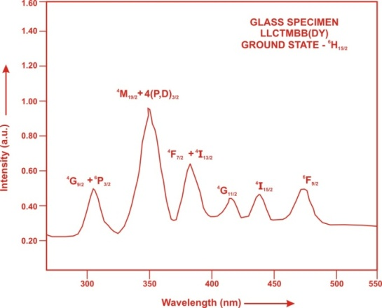
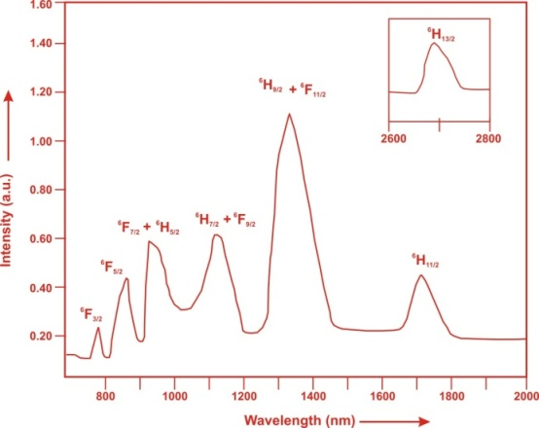
Fig. (2) Absorption spectrum of Dy³⁺doped LLCTMBB glasses

The experimental and calculated oscillator strength for Dy³⁺ ions in LLCTMBB glasses are given in Table 2.

Table 2: Measured and calculated oscillator strength (P_{m}×10⁺⁶) of Dy³⁺ions in LLCTMBB glasses.

Energy level from  ⁶H_{15/2} | Glass  LLCTMBB (DY01) |  | Glass  LLCTMBB (DY1.5) |  | Glass  LLCTMBB (DY02)
 | P_{exp}. | P_{cal}. | P_{exp}. | P_{cal}. | P_{exp}. | P_{cal}.
⁶H_{13/2} | 1.95 | 2.34 | 1.93 | 2.33 | 1.90 | 2.32
⁶H_{11/2} | 1.32 | 1.91 | 1.30 | 1.90 | 1.26 | 1.87
⁶H_{9/2}+⁶F_{11/2} | 10.15 | 10.04 | 10.12 | 10.01 | 10.07 | 9.96
⁶H_{7/2}+⁶F_{9/2} | 5.45 | 5.14 | 5.42 | 5.12 | 5.40 | 5.10
⁶F_{7/2}+⁶H_{5/2} | 4.62 | 4.58 | 4.60 | 3.56 | 4.56 | 3.52
⁶F_{5/2} | 1.20 | 1.59 | 1.18 | 1.57 | 1.16 | 1.55
⁶F_{3/2} | 0.19 | 0.30 | 0.17 | 0.29 | 0.13 | 0.28
⁶F_{9/2} | 0.26 | 0.27 | 0.24 | 0.26 | 0.22 | 0.25
⁴I_{15/2} | 0.24 | 0.66 | 0.21 | 0.65 | 0.18 | 0.64
⁴G_{11/2} | 0.18 | 0.17 | 0.16 | 0.16 | 0.13 | 0.15
⁶F_{7/2}+⁴I_{13/2} | 3.35 | 3.56 | 3.32 | 3.54 | 3.28 | 3.51
⁶M_{19/2}+4(P,D)3/2 | 7.85 | 9.99 | 7.82 | 9.98 | 7.78 | 9.97
⁴G_{9/2}+⁶P_{3/2} | 1.50 | 1.99 | 1.46 | 1.98 | 1.42 | 1.95
r.m.s. deviation | 0.7287 |  | 0.7361 |  | 0.7531

*Low r.m.s. deviation values clearly indicate the accuracy of fitting.

In the Lead Lithium Cadmium Tantalum Magnesium Bismuth Borate glasses Ω_{2,} Ω₄ and Ω₆ parameters decrease with the increase of x from 1 to 2 mol%. The order of magnitude of Judd-Ofelt intensity parameters is Ω₂>Ω₄> Ω₆ for all the glass specimens. The high values obtained for Ω₂ in all glasses indicate that the Dy³⁺ ion is subjected to higher covalency with low symmetry. The spectroscopic quality factor (Ω₄ /Ω₆) related with the rigidity of the glass system has been found to lie between 1.298 and 1.346 in the present glasses.
The values of Judd-Ofelt intensity parameters are given in Table 3.

Table 3: Judd-Ofelt intensity parameters for Dy³⁺ doped LLCTMBB glass specimens

Glass Specimen | Ω₂(pm²) | Ω₄(pm²) | Ω₆(pm²) | Ω₄ /Ω₆ | Ref.
LLCTMBB (DY01) | 2.362 | 1.467 | 1.130 | 1.298 | P.W.
LLCTMBB (DY1.5) | 2.352 | 1.468 | 1.118 | 1.313 | P.W.
LLCTMBB (DY02) | 2.326 | 1.479 | 1.099 | 1.346 | P.W.
NLTB(DY) | 9.86 | 3.39 | 2.41 | 1.407 | [19]
LLTB(DY) | 8.75 | 2.62 | 2.07 | 1.266 | [20]
PKMAF(DY) | 7.04 | 1.73 | 1.57 | 1.102 | [21]

4.3 Excitation Spectrum
The Excitation spectra of Dy³⁺doped LLCTMBB glass specimens have been presented in Figure 3 in terms of Excitation Intensity versus wavelength. The excitation spectrum was recorded in the spectral region 315–465 nm fluorescence at 575nm having different excitation band centered at 322,353, 365, 385, 425, 454 and 473 nm are attributed to the ⁶P_{3/2}, ⁶P_{7/2}, ⁴P_{3/2}, ⁴I_{13/2}, ⁴G_{11/2}, ⁴I_{15/2} and ⁴F_{9/2} transitions, respectively. The highest absorption level is ⁴I_{13/2} and is at 385nm.So this is to be chosen for excitation wavelength.

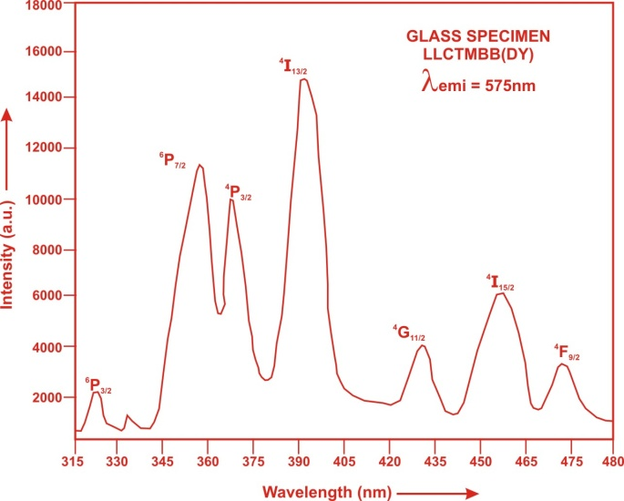

Fig. (3) Excitation spectrum of doped with Dy³⁺ LLCTMBB glasses.

4.4. Fluorescence Spectrum
The fluorescence spectrum of Dy³⁺doped in Lead Lithium Cadmium Tantalum Magnesium Bismuth Borate glass is shown in Figure 4. There are three broad bands observed in the Fluorescence spectrum of Dy³⁺doped Lead Lithium Cadmium Tantalum Magnesium Bismuth Borate glass. The wavelengths of these bands along with their assignments are given in Table 6. The peak with maximum emission intensity appears at 485nm, 575 nm and 665 nm and corresponds to the (⁴F_{9/2}→⁶H_{15/2}), (⁴F_{9/2}→⁶H_{13/2}) and (⁴F_{9/2}→⁶H_{11/2}) transition.

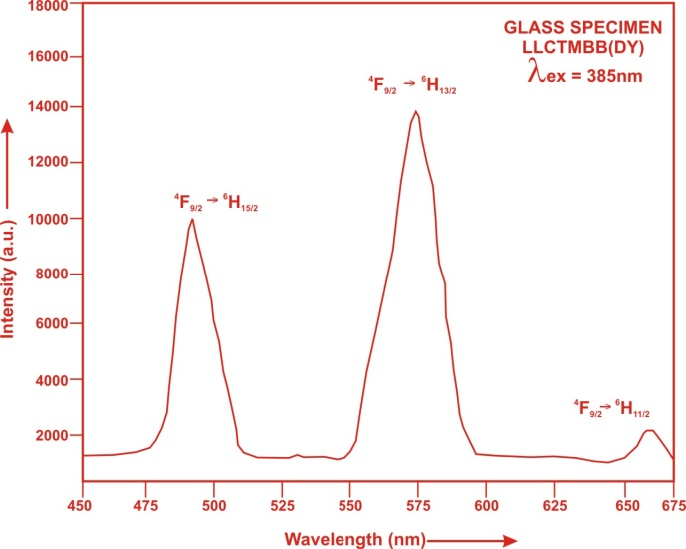

Fig. (4). Fluorescence spectrum of doped with Dy³⁺ LLCTMBB glasses.

Table4: Emission peak wave lengths (λ_{p}),radiative transition probability (A_{rad}),branching ratio (β),stimulated emission cross-section( σ_{p}) and radiative life time( τ_{R} ) for various transitions in Dy³⁺ doped LLCTMBB glasses.

Transition |  | LLCTMBB DY 01 |  |  |  | LLCTMBB DY 1.5 |  |  |  | LLCTMBB DY 02
Transition | λ_{max}  (nm) | A_{rad}(s⁻¹) | β | σ_{p}  (10⁻²⁰ cm²) | τ_{R}(μs) | A_{rad}(s⁻¹) | β | σ_{p}  (10⁻²⁰ cm²) | τ_{R} (μs) | A_{rad}(s⁻¹) | β | σ_{p} (10⁻²⁰ cm²) | τ_{R} (10⁻²⁰ cm²)
⁴F_{9/2}→⁶H_{15/2} | 485 | 97.3987 | 0.2065 | 0.165 | 2119.68 | 96.664 | 0.2058 | 0.160 | 2129.32 | 95.6674 | 0.2056 | 0.154 | 2149.53
⁴F_{9/2}→⁶H_{13/2} | 575 | 338.453 | 0.7174 | 1.211 | 2119.68 | 337.170 | 0.7179 | 1.175 | 2129.32 | 334.045 | 0.7180 | 1.136 | 2149.53
⁴F_{9/2}→⁶H_{11/2} | 665 | 35.9168 | 0.07613 | 0.145 |  | 35.8005 | 0.07623 | 0.143 |  | 35.5065 | 0.07632 | 0.138
V. Conclusion

In the present study, the glass samples of composition (35-x) Bi₂O₃:10PbO:10 Li₂O:10 CdO: 10Ta₂O₅:10MgO:15 B₂O₃:xDy₂O₃ (where x =1, 1.5and 2mol %) have been prepared by melt-quenching method. The value of stimulated emission cross-section (σ_{p}) is found to be maximum for the transition (⁴F_{9/2}→⁶H_{13/2}) for all glass specimens. This
shows that (⁴F_{9/2}→⁶H_{13/2}) transition is most probable transition.

References
[1] Tanabe, S., Kang, J., Hanada, T., Soga, N.(1998).“Yellow/blue luminescence of Dy³⁺ doped borate glasses and their anomalous temperature variations”, J Non-Cryst Solids, 239:170.
[2] Alajerami,Y.S.M., Hashim,S., Hassan,W. M. S., Ramli, A. T., Kasim, A. (2012) .Optical properties of lithium magnesium borate glasses doped with Dy³⁺ and Sm³⁺ ions, Physica B 407, 2398– 2403.
[3] Kumar,M. V., Jamalaiah, B. C., Gopal, K. R., Reddy, R. R. (2012).Optical absorption and fluorescence studies of Dy³⁺- doped lead telluroborate glasses, J. Lumin. 132, 86-90.
[4] Rajesh,D., Balakrishna,A. Ratnakaram, Y.C. (2012). Luminescence, structural and dielectric properties of Sm³⁺ impurities in strontium lithium bismuth borate glasses. Opt. Mat. 35, 108–116.
[5] Ratnakaram, Y.C., Thirpathi, N.D. and Chakaradhar, R.P.S.(2006).Spectral studies of Sm³⁺ and Dy³⁺ doped lithium cesium mixed alkali borate glasses.J.Non-cryst.Solids,352,3914.
[6]. Lin, H., Pun, E.Y.B. and Wang, X.J. (2005). Intense visible fluorescence and energy transfer in Dy³⁺, Tb³⁺, Sm³⁺ and Eu³⁺ doped rare-earth borate glasses. J. Alloy. Compd., 390,197.
[7]. Rao, K.V., Babu, S. , Venkataiah, G. , Ratnakaram, Y. C. (2015) “Optical Spectroscopy of Dy³⁺ doped borate glasses for luminescence applications”, Journal of Molecular Structure 1094,274-280.
[8] Gedam,R. S., Ramteke, D. D. (2012).Electrical and optical properties of lithium borate glasses doped with Nd₂O₃, J. Rare Earths 30 (8) , 785-789.
[9] Gedam, R. S., Ramteke, D. D. (2013). Influence of CeO₂ addition on the electrical and optical properties of lithium borate glasses, J. Phys. Chem.Solids 74, 1399-1402.
[10] George, J. L. (2015). Dissolution of borate glasses and precipitation of phosphate compounds. Spring, 1-191.
[11] Zang, X. M., Li, D. S., Pun,E. Y. B.,and Lin,H.(2017). Dy³⁺ doped borate glasses for laser illumination, Optical Material Express, Vol.7(6),pp-2040-2054.
[12]. Dahiya, M.S., Khasa,S. and Agarwal,A. (2015).Physical, thermal, structural and optical absorption studies of vanadyl doped magnesium oxy-chloride bismo-borate glasses . Journal of Asian Ceramic Societies 3, 206–211.
[13]. Mariselvam,K.,Kumar,A.,Anuradha,M.and Panigrahi,B.S.(2017). Synthesis and photoluminescence behaviour of
dysprosiumdoped barium bismuth borate glasses.Opto. Electronocs and Adv.Material, Vol.11, pp-462-466.

[14]Parandamaiah,M.(2015). Dy³⁺ doped Lithium Sodium Bismuth Borate Glasses for Yellow Luminescent Photonic Applications, Vol.5(8),pp.126-131.
[15]. Gorller-Walrand, C. and Binnemans, K. (1988) Spectral Intensities of f-f Transition. In: Gshneidner Jr., K.A. and Eyring,L., Eds., Handbook on the Physics and Chemistry of Rare Earths, Vol. 25, Chap. 167, North-Holland, Amsterdam, 101-264.
[16]. Sharma, Y.K., Surana, S.S.L. and Singh, R.K. (2009) Spectroscopic Investigations and Luminescence Spectra of Sm³⁺ Doped Soda Lime Silicate Glasses. Journal of Rare Earths, 27, 773.
[17]. Judd, B.R. (1962). Optical Absorption Intensities of Rare Earth Ions. Physical Review, 127, 750.
[18]. Ofelt, G.S. (1962). Intensities of Crystal Spectra of Rare Earth Ions. The Journal of Chemical Physics, 37, 511. [19] Saleema,S.A. , Jamalaiah, B.C., Jayasimhadri, M., Rao,A. S., Jang, K., Moorthy,L. R. (2011). Journal of
Quantitative Spectroscopy & Radiative Transfer, pp.78–84.
[20]S.A. Saleema, B.C. Jamalaiah, M. Jayasimhadri, A. Srinivasa Rao, Kiwan Jang, L. Rama Moorthy. “Luminescent studies of Dy³⁺ ion in alkali lead tellurofluoroborate glasses”, Journal of Quantitative Spectroscopy & Radiative Transfer, pp. 78–84 2011.
[21]Sardar, D.K., Bradley, W.M., Yow, R.M. Gruber, J.B., Zandi, B. (2004). “Optical transitions and absorption intensities of Dy³⁺ (⁴f₉) in YSGG laser host”, J Lumin, 106, pp.195–203.

