Spectral and Raman Analysis of Nd³⁺ Doped Zinc Lithium Sodalime Cadmium Borosilicate Glasses
S.L.Meena
Ceremic Laboratory, Department of physics, Jai Narain Vyas University, Jodhpur 342001(Raj.) India
E-mail address:shankardiya7@rediffmail.com

Abstract
Glass of the system: (35-x) SiO₂:10ZnO:10Li₂O:10CaO:10Na₂O:10CdO:15B₂O₃: xNd₂O_{3.} (where x=1, 1.5,2 mol %) have been prepared by melt-quenching method. The amorphous nature of the glasses was confirmed by X-ray diffraction studies. Optical absorption, Excitation, fluorescence and Raman spectra have been recorded at room temperature for all glass samples.Slater-Condon parameters F_{k} (k=2, 4, 6), Lande’s parameter ξ_{4f} and Racah parameters E^{k} (k=1, 2, 3) have been computed. Using these parameters energies and intensities of these bands has been calculated. Judd-Ofelt intensity parameters Ω_{λ} (λ=2, 4, 6) are evaluated from the intensities of various absorption bands of optical absorption spectra. Using these intensity parameters various radiative properties like spontaneous emission probability (A), branching ratio (β_{R}), radiative life time (τ) and stimulated emission cross–section (σ_{p}) of various emission lines have been evaluated.
Keywords: ZLSLCBS Glasses, Optical Properties, Judd-Ofelt Theory, Raman spectra.
1. Introduction
Rare earth doped phosphate glasses are being extensively studied due to their technological importance and their applications in the field of glass ceramics, thermal and mechanical sensors, reflecting windows [1-5]. Among different host matrices, silicate glasses are quite prone with the advantages such as low non-linear refractive index, good physical and chemical stability and high transparency from near Ultra Violet to mid-Infrared region [6-11]. Due to their good chemical durability, neodymium-doped soda-lime silicate glasses are attractive materials for the fabrication of low-cost integrated optical amplifiers by using the ion-exchange technique. Glasses contain B₂O₃ have received increased attention due to their application in the field of glass ceramics, reflecting windows, thermal and mechanical sensors [12-14]. The addition of network modifier (NWF) Li₂O is to improve both electrical and mechanical properties of such glasses. Silicate glasses also exhibit high RE ions solubility [15]. Nd³⁺ doped materials have proven to be among the most efficient candidates for photonic devices, such as lasers and planer wave guides [16-20].
In the present work, Optical absorption, Excitation, fluorescence and Raman spectra have been recorded at room temperature for all glass samples. From the spectral data various energy interaction parameters like Slater-Condon parameters F_{k} (k=2, 4, 6), Lande’s parameter ξ_{4f} and Racah parameters E^{k} (k=1, 2, 3) have been computed. The Judd-Ofelt theory has been applied to compute the intensity parameters Ω_{λ} (λ=2, 4, 6).To understand the laser efficiency of these materials, the value of spectroscopy quality factor (Ω₄/ Ω₆) has been evaluated.

2. Experimental
The following Nd³⁺ doped borosilicate glass samples (35-x) SiO₂:10ZnO:10Li₂O:10CaO:10Na₂O:10CdO:15B₂O₃: xNd₂O_{3.}(where x =1, 1.5, 2) have been prepared by melt-quenching method. Analytical reagent grade chemical used in the present study consist of SiO₂, ZnO, Li₂O, CaO, Na₂O, CdO, B₂O₃ and Nd₂O₃. They were thoroughly mixed by using an agate pestle mortar. Then melted at 1075˚C by an electrical muffle furnace for 2 hours. After complete melting, the melts were quickly poured in to a preheated stainless steel mould and annealed at temperature of 350˚C for 2 h to remove thermal strains and stresses. Every time fine powder of cerium oxide was used for polishing the samples. The glass samples so prepared were of good optical quality and were transparent. The chemical compositions of the glasses with the name of samples are summarized in Table 1.

Table 1. Chemical composition of the glasses.

Sample Glass composition (mol %)
ZLSLCBS (UD) 35 SiO₂:10ZnO:10Li₂O:10CaO:10Na₂O:10CdO:15B₂O₃:
ZLSLCBS (ND1) 34SiO₂:10ZnO:10Li₂O:10CaO:10Na₂O:10CdO:15B₂O₃:1Nd₂O₃
ZLSLCBS (ND1.5) 33.5SiO₂:10ZnO:10Li₂O:10CaO:10Na₂O:10CdO:15B₂O₃:1.5Nd₂O₃
ZLSLCBS (ND2) 33 SiO₂:10ZnO:10Li₂O:10CaO:10Na₂O:10CdO:15B₂O₃:2Nd₂O₃
.
ZLSLCBS (UD)-Represents undoped Zinc Lithium Sodalime Cadmium Borosilicate glass specimen.
ZLSLCBS (ND)-Represents Nd³⁺ doped Zinc Lithium Sodalime Cadmium Borosilicate glass specimens.
III. Theory

3.1Oscillator Strength
The intensity of spectral lines are expressed in terms of oscillator strengths using the relation [21].

f_{expt}. = 4.318 ×10⁻⁹∫ε (ν) dν (1)

where, ε (ν) is molar absorption coefficient at a given energy ν (cm⁻¹), to be evaluated from Beer–Lambert law.
Under Gaussian Approximation, using Beer–Lambert law, the observed oscillator strengths of the absorption bands have been experimentally calculated [22], using the modified relation:
P_{m}=4.6 ×10⁻⁹×log ×Δυ_{1/2} (2)

where c is the molar concentration of the absorbing ion per unit volume, I is the optical path length, logI₀/I is optical density and Δυ_{1/2}is half band width.

3.2 Judd-Ofelt Intensity Parameters
According to Judd[23] and Ofelt[24] theory, independently derived expression for the oscillator strength of the induced forced electric dipole transitions between an initial Jmanifold │4f^{N} (S, L) J> level and the terminal J' manifold │4f^{N} (S', L') J'> is given by:
(3)
Where, the line strength S (S', L') is given by the equation
S (J, J') =e² ∑Ω_{λ}<4f ^{N}(S, L) J║U ^{(λ)} ║4f^{N}(S', L')J'>2 (4)
λ =2, 4, 6
In the above equation m is the mass of an electron, c is the velocity of light, ν is the wave number of the transition, h is Planck’s constant, n is the refractive index, J and J' are the total angular momentum of the initial and final level respectively, Ω_{λ} (λ = 2, 4, 6) are known as Judd-Ofelt intensity parameters.

3.3 Radiative Properties
The Ω_{λ} parameters obtained using the absorption spectral results have been used to predict radiative properties such as spontaneous emission probability (A) and radiative life time (τ_{R}), and laser parameters like fluorescence branching ratio (β_{R}) and stimulated emission cross section (σ_{p}).

The spontaneous emission probability from initial manifold │4f^{N}(S', L') J'> to a final manifold │4f^{N} (S,L) J >| is given by:

A[(S', L') J'; (S,L)J]=$\frac{64 π^{2}ν^{3}}{3h\left(2J^{'}+1\right)}\left\lfloor \frac{n{\left(n^{2}+2\right)}^{2}}{9}\right\rfloor ×S (J', J)$ (5)

where, S (J', J) = e² [Ω₂║U ⁽²⁾ ║² + Ω₄║U ⁽⁴⁾ ║² + Ω₆║U ⁽⁶⁾ ║²]

The fluorescence branching ratio for the transitions originating from a specific initial manifold │4f^{N} (S', L') J'> to a final many fold│4f^{N} (S,L)J > is given by

β[(S', L') J'; ( S , L ) J] = ∑ $\frac{A\left[\left(S^{'} L\right)\right]}{A\left[\left(S^{'}{ L}^{'}\right)J^{'}\left(\overline{S} L\right)\right]}$ (6)
S L J
where, the sum is over all terminal manifolds.

The radiative life time is given by
τ_{rad} = ∑ A[(S', L') J'; (S,L ) ] = $A_{Total}^{-1}$ (7)
S L J

where, the sum is over all possible terminal manifolds. The stimulated emission cross -section for a transition from an initial manifold │4f^{N} (S', L') J'> to a final manifold│4f^{N} (S,L)J>| is expressed as
${ σ}_{p}\left(λ_{p}\right)=\left[\frac{λ_{p}^{4}}{8πcn^{2}Δλ_{eff}}\right]×A\left[\left(S^{'},L^{'}\right)J^{'};\left(\overline{S}, \overline{L}\right)\overline{J}\right]$ (8)

where,$λ_{p}$ the peak fluorescence wavelength of the emission band and $Δλ_{eff}$ is the effective fluorescence line width.

3.4 Nephelauxetic Ratio (β) and Bonding Parameter (b^{1/2})
The nature of the R-O bond is known by the Nephelauxetic Ratio (β') and Bonding
Parameters (b^{1/2}), which are computed by using following formulae [25, 26]. The Nephelauxetic Ratio is given by
${ β}^{'}=\frac{ν_{g}}{ν_{a}}$ (9)

where, ν_{a} and ν_{g} refer to the energies of the corresponding transition in the glass and free ion, respectively. The values of bonding parameter $b^{1/2}$ are given by

$b^{1/2}={\left\lfloor \frac{1-β^{'}}{2}\right\rfloor }^{1/2}$ (10)

IV.Result and Discussion

4.1. XRD Measurement
Figure 1 presents the XRD pattern of the samples shows no sharp Bragg’s peak, but only a broad diffuse hump around low angle region. This is the clear indication of amorphous nature within the resolution limit of XRD instrument.
Fig.1: X-ray diffraction pattern of SiO₂:ZnO:Li₂O:CaO:Na₂O:CdO:B₂O₃: :Nd₂O₃ glasses.

4.2 Raman spectra
The Raman spectrum of Zinc Lithium Sodalime Cadmium Borosilicate (ZLSLCBS) glass specimens is recorded and is shown in Fig. 2. The spectrum peaks located at 602, 795 and 1204 cm⁻¹. The band at 602 and 795cm⁻¹ assigned to Si–O–Si symmetric stretching and bending vibration, respectively. The band at 1204 cm⁻¹ assigned to Si–O–Si asymmetric stretching.

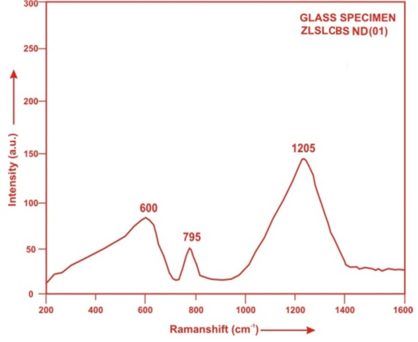
Fig.2 Raman spectrum of ZLSLCBS ND (01) glass.
4.3. Absorption spectra
The absorption spectra of ZLSLCBS (ND 01) glass, consists of absorption bands corresponding to the absorptions from the ground state ⁴I_{9/2} of Nd³⁺ ions. Nine absorption bands have been observed from the ground state ⁴I_{9/2} to excited states ⁴F_{3/2}, ⁴F_{5/2}, ⁴F_{7/2}, ⁴F_{9/2}, ²H_{11/2}, ⁴G_{5/2}, ⁴G_{7/2}, ⁴G_{9/2}, and ²G_{9/2} for Nd³⁺ doped ZLSLCBS (ND 01) glass.
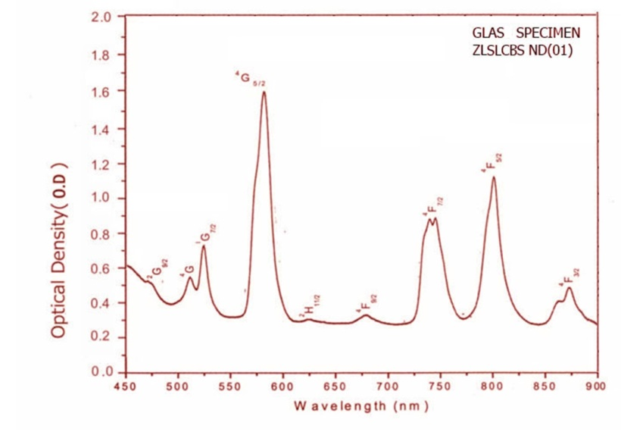
Fig.3: Vis-NIR absorption spectra of ZLSLCBS (ND 01) glass.
The experimental and calculated oscillator strengths for Nd³⁺ ions in zinc lithium sodalime cadmium borosilicate glasses are given in Table 2.

Table 2. Measured and calculated oscillator strength (P^{m} × 10⁺⁶) of Nd³⁺ ions in ZLSLCBS glasses.
Energy level from  ⁴I_{9/2} | Glass ZLSLCBS  (ND01) |  | Glass ZLSLCBS  (ND1.5) |  | Glass ZLSLCBS  (ND02)
 | P_{exp.} | P_{cal.} | P_{exp.} | P_{cal.} | P_{exp.} | P_{cal.}
⁴F_{3/2} | 4.38 | 4.03 | 3.42 | 3.38 | 2.64 | 2.76
⁴F_{5/2} | 8.24 | 8.51 | 7.44 | 7.46 | 6.44 | 6.44
⁴F_{7/2} | 8.94 | 9.03 | 7.83 | 8.14 | 6.73 | 7.26
⁴F_{9/2} | 0.64 | 0.51 | 0.55 | 0.45 | 0.43 | 0.40
²H_{11/2} | 0.24 | 0.15 | 0.21 | 0.13 | 0.12 | 0.11
⁴G_{5/2} | 25.43 | 25.62 | 24.33 | 24.58 | 23.28 | 23.70
⁴G_{7/2} | 4.68 | 5.44 | 3.89 | 4.81 | 2.63 | 4.21
⁴G_{9/2} | 2.83 | 2.39 | 2.25 | 2.05 | 1.43 | 1.73
²G_{9/2} | 0.94 | 3.12 | 0.82 | 2.64 | 0.62 | 2.19
R.m.s.deviation | 0.8009 |  | 0.6981 |  | 0.7811

The various energy interaction parameters like Slater-Condon parameters F_{k} (k=2, 4, 6), Lande’s parameter ξ_{4f} , Racah parameters E^{k} (k=1, 2, 3), nephelauexetic ratio and bonding parameter for Nd³⁺ doped ZLSLCBS glass specimens are given in Table 3.
Table3. Computed values of Slater-Condon, Lande′, Racah, nephelauexetic ratio and bonding parameter for Nd³⁺ doped ZLSLCBS glass specimens.

Parameter | Free ion | ZLSLCBS  ( ND01) | ZLSLCBS  (ND1.5) | ZLSLCBS  ( ND02)
F₂(cm⁻¹) | 331.16 | 327.29 | 327.17 | 327.23
F₄(cm⁻¹) | 50.71 | 49.91 | 49.94 | 49.93
F₆(cm⁻¹) | 5.154 | 5.137 | 5.131 | 5.134
ξ_{4f}(cm⁻¹) | 884.0 | 889.48 | 889.35 | 889.23
E¹(cm⁻¹) | 5024.0 | 4969.20 | 4967.90 | 4968.78
E²(cm⁻¹) | 23.90 | 23.73 | 23.69 | 23.71
E³(cm⁻¹) | 497.0 | 489.48 | 489.51 | 489.50
F₄/F₂ | 0.1531 | 0.1525 | 0.1526 | 0.1526
F₆/F₂ | 0.0155 | 1.569 | 0.01568 | 0.01569
E¹/E³ | 10.1086 | 10.16 | 10.15 | 10.15
E²/E³ | 0.0481 | 0.0485 | 0.00484 | 0.00484
β' |  | 0.98832  0.0076398 | 0.98796  0.0077583 | 0.988135  0.0077024
b^{1/2}

Judd-Ofelt intensity parameters Ω_{λ} (λ = 2, 4 and 6) were calculated by using the fitting approximation of the experimental oscillator strengths to the calculated oscillator strengths with respect to their electric dipole contributions. In the present case the three Ω_{λ} parameters follow the trend Ω₂ < Ω₆ < Ω₄.
The values of Judd-Ofelt intensity parameters are given in Table 4.
Table 4. Judd-Ofelt intensity parameters for Nd³⁺ doped ZLSLCBS glass specimens.
Glass Specimen | Ω₂(pm²) | Ω₄(pm²) | Ω₆(pm²) | Ω₄/Ω₆
ZLSLCBS ( ND01) | 1.718 | 7.945 | 2.848 | 3.204
ZLSLCBS (ND1.5) | 2.401 | 6.617 | 2.607 | 2.538
ZLSLCBS (ND02) | 3.092 | 5.339 | 2.367 | 2.256

4.4 Excitation Spectrum
The Excitation spectra of Nd³⁺doped ZLSLCBS ND (01) glass specimen has been presented in Figure 4 in terms of Excitation Intensity versus wavelength. The excitation spectrum was recorded in the spectral region 700–1000 nm fluorescence at 1065nm having different excitation band centered at 808 nm and 887 nm are attributed to the (⁴I_{9/2}→⁴F_{5/2}) and (⁴I_{9/2}→⁴F_{3/2}) transitions, respectively. The highest absorption level is ⁴F_{5/2} and is at 808 nm. So this is to be chosen for excitation wavelength.
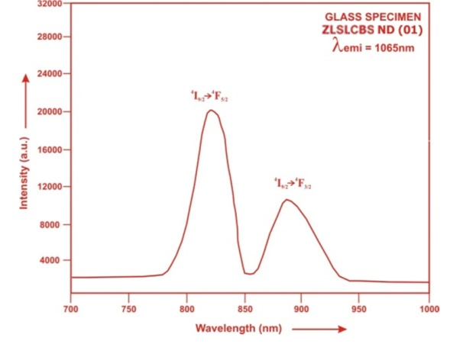
Fig.4: Excitation spectra of ZLSLCBS ND (01) glass
4.5. Fluorescence Spectrum
The fluorescence spectrum of Nd³⁺doped in zinc lithium sodalime cadmium borosilicate glass is shown in Figure 5. There are six broad bands (⁴G_{7/2}→⁴I_{9/2}) (⁴G_{7/2}→⁴I_{11/2}), (⁴F_{3/2}→⁴I_{9/2}), (⁴F_{3/2}→⁴I_{11/2}), (⁴F_{3/2}→⁴I_{13/2}) and (⁴F_{3/2}→⁴I_{15/2}) respectively for glass specimens.

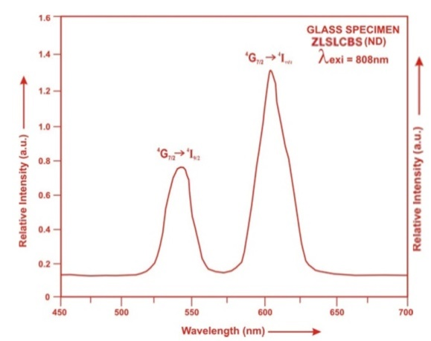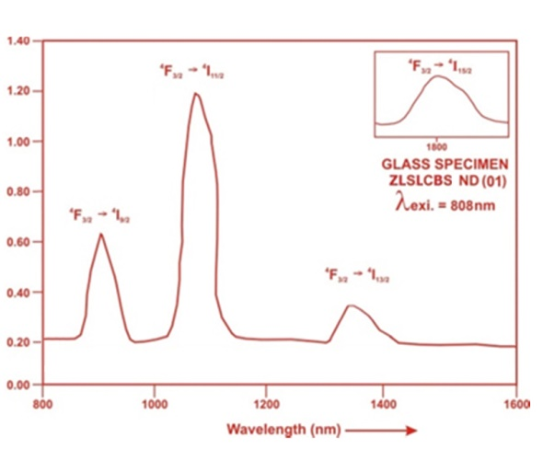

Fig.5: Fluorescence spectra of ZLSLCBS ND (01) glass.
The wavelengths of these bands along with their assignments are given in Table 5.

Table 5. Emission peak wave lengths (λ_{p}), radiative transition probability (A_{rad}), branching ratio (β_{R}), stimulated emission crosssection (σ_{p}), and radiative life time (τ) for various transitions in Nd³⁺ doped ZLSLCBS glasses.

ZLSLCBS (ND01) ZLSLCBS (ND01) ZLSLCBS (ND01)

Transition | λ_{p}(nm) | A_{rad}(s⁻¹) | β_{R} | σ_{p}  (10⁻²⁰cm²) | τ_{R}( μs) | A_{rad}(s⁻¹) | β_{R} | σ_{p}  (10⁻²⁰cm²) | τ_{R}( μs) | A_{rad}(s⁻¹) | β_{R} | σ_{p}  (10⁻²⁰cm²) | τ_{R}( μs)
⁴G_{7/2}→⁴I_{9/2} | 532 | 3877.10 | 0.4422 | 0.494 |  | 3384.80 | 0.4207 | 0.458 |  | 2956.54 | 0.3965 | 0.414
⁴G_{7/2}→⁴I_{11/2} | 595 | 3263.30 | 0.3799 | 1.144 |  | 3309.47 | 0.4114 | 1.231 |  | 3370.14 | 0.4519 | 1.327
⁴F_{3/2}→⁴I_{9/2} | 905 | 983.69 | 0.1133 | 0.866 | 115.22 | 827.30 | 0.1028 | 0.746 | 124.30 | 676.07 | 0.0907 | 0.631 | 134.10
⁴F_{3/2}→⁴I_{11/2} | 1075 | 517.28 | 0.0596 | 2.174 |  | 452.94 | 0.0563 | 2.035 |  | 389.94 | 0.0523 | 1.884
⁴F_{3/2}→⁴I_{13/2} | 1320 | 75.39 | 0.00869 | 0.378 |  | 69.13 | 0.0085 | 0.366 |  | 62.89 | 0.0084 | 0.345
⁴F_{3/2}→⁴I_{15/2} | 1800 | 1.80 | 0.0002 | 0.0224 |  | 1.65 | 0.0002 | 0.0209 |  | 1.50 | 0.0002 | 0.0194

V. Conclusion
In the present study, the glass samples of composition (35−x)SiO₂:10ZnO: 10Li₂O:10CaO:10Na₂O:10CdO:15B₂O₃:xNd₂O₃ (where x =1, 1.5, 2 mol %) have been prepared by melt-quenching method. The value of stimulated emission cross-section (σ_{p}) is found to be maximum for the transition (⁴F_{3/2}→⁴I_{11/2}) for glass ZLSLCBS (ND 01), suggesting that glass ZLSLCBS (ND 01) is better compared to the other two glass systems ZLSLCBS (ND1.5) and ZLSLCBS (ND02). The large stimulated emission cross section in silicate glasses suggests the possibility of utilizing these systems as laser materials.

References

[1]. Murthy Goud, K. K., Ramesh C.H. and Rao, B. A.(2017). Up conversion and Spectroscopic Properties of Rare Earth Codoped Lead Borate Glass Matrix. Material Science Research India, 14, 140-145.
[2].Mohan, S. and Thind, K. S. (2017). Optical and spectroscopic properties of neodymium doped cadmium-sodium borate glasses Opt, Laser Technol. 95, 36–41
[3]. Lin, H., Pun, E.Y.B. and Wang, X.J. et al.(2005). Intense visible fluorescence and energy transfer in Dy3⁺, Tb3⁺, Sm³⁺ and Eu³⁺ doped rare-earth borate glasses. J. Alloy. Compd., 390,197-201.
[4]. Ramteke, D.D., Annapurna, K., Deshpande, V.K. and Gedam, R.S. (2014). Effect of Nd³⁺ on spectroscopic properties of lithium borate glasses. J. Rare Earths 32(12), 1148-1153
[5]. Karthikeyan, B. and Mohan, S. (2003). Structural, optical and glass transition
studies on Nd³⁺-doped lead bismuth borate glasses, Physica B, 334, 298–302.
[6].Verma, B.R. , Baghel, R.N.(2017). Structural and optical properties of Eu³⁺
doped silicate phosphors, Indian Journal of Pure Applied Physics, 13, 477-483
[7]. Yasukevich, A. S., Rachkovskaya, G.E., Zakharen, G.B., Trusova,E.E., Kornienko,A. A., Dunina,E.B., Kisel,V. E.and Kuleshov, N. V. (2020).spectral luminescence properties of oxyfluoride lead silicate germante glass doped with ${Tm}^{3+}$ ions, Journal of luminescence, 117667.
[8]. Monisha, M., Nancy,A. , Souza, D., Nimitha ,V. L., Prabhu, S and Sayyed, M.I.(2020). Dy³⁺ doped SiO₂- B₂O₃-Al₂O₃-NaF-ZnF₂ glasses: An exploration of optical and gamma radiation shielding features, Current Applied Physics 20(11), 1207-1210.
[9]. Chimalawong, P., Kaewkhao, J., Kedkaew, C. and Limsuwan, P. (2010). Optical and ElectronicPolarizability Investigation of Nd³⁺-Doped Soda-Lime Silicate Glasses. Journal of Physics and Chemistry of Solids, 71, 970.
[10]. Rao,T.G.V.M., Kumar, A. R., Neeraja, K., Veeraiah, N.and Reddy, M.R.(2013).Optical and structural investigation of Eu³⁺ ions in Nd³⁺ co-doped magnesium lead borosilicate glasses, J. Alloy. Compd. 557,209–217.
[11]. Berneschi ,S. , Bettinelli ,M., Brenci , M. , Dall’Igna ,R., Nunzi Conti ,G., Pelli ,S., Profilo ,B. , Sebastiani ,S., Speghini , A. and Righini, G.C.(2006).Optical and spectroscopic properties of soda-lime alumino silicate glasses doped with Er³⁺ and/or Yb³⁺, Optical Materials 28,1271–1275
[12]. Li,H. Z., Xin,Y. S., Hua Mao, Ri, H. Chen, Hao, Jun Zhang ,Zhi. and Tai Zhao, Jing (2014). Luminescence properties of Ce³⁺-doped lithium borophosphate glasses and their correlations with the optical basicity, Journal of Non-Crystalline Solids 403, 1–4.
[13].Sharma, Y.K., Tandon,S.P. and Surana, S.S.L.(2000).Laser action in praseodymium doped zinc chloride borophosphate glasses. Materials Science and Engineering B77, 167-171.
[14]. Gedam, R. S.and Ramteke, D. D. (2013). Influence of CeO₂ addition on the electrical and optical properties of lithium borate glasses, J. Phys. Chem. Solids 74, 1399-1402.
[15]. Weber, M.J. (1990). Science and technology of laser glass. J. Non-Cryst.
Solids, 123, 208–222.
[16]. Dousti, M.R. , Poirier, G.Y.and de Camargo, A.S.S.,(2020).Tungsten Sodium Phosphate glasses doped with trivalent rare earth ions (Eu³⁺, Tb³⁺, Nd³⁺, Er³⁺ ) for visible and near infrared applications, Journal of Non- Crystalline Solids 530, 119838.
[17]. Reddy, M. S., Uchil, J., Reddy, C. N.(2014).Thermal and Optical properties of Sodium-Phospho- Zinc-Neodymium oxide glass system, Journal of Advanced Scientific Research, 5(2), 32-39.
[18]. Manasa, P, Srihari, T, Basavapoornima, C., Joshi, A .S. and Jayasankar, C. K .(2019). Spectroscopic investigations of Nd³⁺ ions in niobium phosphate glasses for laser applicationsJ. Lumin. 211, 233–42.
[19]. Vighnesh, K.R., Ramya, B., Nimitha, S., Wagh,A., Sayyed, M.I., Sakar, E., Yakout, H.A. and Dahshan, A. (2020).Structural, optical, thermal, mechanical, morphological and radiation shielding parameters of Pr³⁺ doped ZAIFB glass systems, optical materials 99,109512.
[20]. Campbell, J.H., Suratwala, T.I. (2000). Nd³⁺-doped phosphate glasses for high-energy/high-peak-power lasers.J. Non-Cryst. Solids, 263, 318–341.
[21]. Gorller-Walrand, C. and Binnemans, K. (1988) Spectral Intensities of f-f Transition. In: Gshneidner Jr., K.A. and Eyring,L., Eds., Handbook on the Physics and Chemistry of Rare Earths, Vol. 25, Chap. 167, North-Holland, Amsterdam, 101.
[22].Sharma, Y.K., Surana, S.S.L. and Singh, R.K. (2009). Spectroscopic Investigations and Luminescence Spectra of Sm³⁺ Doped Soda Lime Silicate Glasses. Journal of Rare Earths, 27, 773.
[23].Judd, B.R. (1962). Optical Absorption Intensities of Rare Earth Ions.Physical Review, 127, 750.
[24].Ofelt, G.S. (1962). Intensities of Crystal Spectra of Rare Earth Ions. The Journal of Chemical Physics, 37, 511.
[25].Sinha, S.P. (1983).Systematics and properties of lanthanides, Reidel, Dordrecht.
[26]. Krupke,W.F.(1974).Induced- emission cross-section in neodymium laser glasses. IEEE J. Quantum electron QE-10,450-457.

