Temperature and Frequency Dependent Dielectric and AC Conducting Parameters of Phospovanadate Glasses
B. M. Shelke¹, R. V. Barde^{2*}, P. R. Malasane³, and M. E. Shelke⁴
¹ Department of Electronics Engineering, Government Polytechnic, Amravati.
²Department of Physics, Government Vidarbha Institute of Science and Humanities, Amravati 444 604, India.
³Department of Applied Sciences and Humanities, Sipna College of Engineering and Technology, Amravati 444605, India.
⁴ Department of Chemistry, Government Vidarbha Institute of Science and Humanities, Amravati 444 604, India.
* Corresponding Author E-mail: rajeshbarde1976@gmail.com
Abstract
The studies of impedance spectroscopic of phospho-vanadate glasses were carried out over a wide frequency range 20 Hz–1 MHz and temperature range from R.T to 200°C. For lower frequencies, AC conductivity is almost frequency independent because electron hopping is overcome in this range, while at upper frequencies it is almost frequency dependent and rises in a fashion of power law and attains linearity at higher frequencies. The highest conductivity was found to be 9.29×10⁻⁴ S.cm⁻¹, for P2 at 473 K. The value of the frequency exponent and its temperature dependence confirmed the applicability of the CBH model. In the upper frequency region, the imaginary dielectric constant obeys the Debye model.
Keywords: AC conductivity; Glass; Power law; Hopping.
- Introduction
The unexpectedly increasing populace and urbanization call for extra power. Hence, present day want is to broaden diverse procedures to broaden sustainable power and rechargeable batteries are one such stressful method. One such mild supply is semiconducting transition metallic oxide, like vanadate-primarily based totally glasses, as they show off unique oxidation states [1, 2]. In solid state ionic, many researchers are attracted towards the process of ionic conductivity because of very large demand for fast ion conductors in glassy electrolytes [3]. From the structure of the glass network, mechanical properties were prejudiced. The high density of non-bridging oxygen (NBO) creates a more open structure, which lowers the mechanical strength and glass hardness [4]. From NMR and EPR techniques, it is clear that V₂O₅ exhibits 4 and 5-fold coordination, in which the polaronic and ionic conductivity are detected [5]. Many researchers reported that V₂O₅ enhanced the conductivity of glasses. Vanadiun pentaoxide is the provisional glass former hence to form a glass it needs another glass former [6, 7].
Nowadays, research is focused on the study of various materials that have specific properties like light absorption and electrical signal transmission. Among them, phosphate glasses show sensible mechanical and electrical properties [8]. In phospho-vanadate glasses, conduction is described by the phonon assisted hopping of electrons (small polaron hopping) between the low (V⁴⁺) and high (V⁵⁺) valence states of vanadium glasses [9]. The vanadate and phosphate glasses have piqued interest as they exhibit excessive glass-forming performance, low transition temperature, low melting point, excessive thermal growth coefficients, excessive infrared transmission, and excessive dielectric constant [10].
In glasses, impedance (IS) measurement is a useful method for examination of movement of ion with a frequency between a few hertz to some megahertz. Information concerning conduction and the delivery mechanism may be acquired via way of means of converting the temperature, because it has a link with the alternate in network structure and mobility of the enhancing ions. The IS facts may be molded in phrases of equal circuits, which offers perception concerning delivery mechanisms of substances and tool operation. The impedance plot is projected to be a semicircle [11]. This work presents the evaluation of temperature and frequency dependent AC conductivity, dielectric results, and Cole–Cole analysis of V₂O₅-P₂O₅ glasses withinside the frequency varies in between 20Hz to 1MHz and temperature in between 308 K to 473 K. The structural properties were examined by XRD.
- Materials and Methods
Glasses of (100-x)V₂O₅-xP₂O₅ (x = 20, 40, 50, 60 and 80 mol %) were prepared via regular melt quenching method. For the preparation of glasses with 99% purity, SD fine vanadium pentoxide (V₂O₅) and phosphorus pentoxide (P₂O₅) were used as raw materials. These two chemical compounds had been very well mixed together in an agate mortar and melted in an electric powered furnace at 900 °C for 180 min. in a silica crucible in order to get the homogeneously blended soften melt. After the quenching, the samples have been annealed at 200 °C for 60 min. after which slowly cooled till ambient temperature to limit the inner mechanical stress and attain glasses with desirable mechanical stability. These samples of about thickness 3 mm were polished carefully for electrical measurements. AC conductivity and dielectric constant were measured via way of means of the usage of LCR meter, Agilent Technologies, Singapore. The measurements have been finished in a frequency and temperature vary between 20 Hz to one MHz and a 308–473 K respectively. These glass samples were named as P1, P2, P3, P4 and P5 for 20, 40, 50, 60, and 80 mol % of P₂O₅.
- Results and Discussion
3.2 AC conductivity measurements
The distinctive impedance plots for P2 glass sample are shown in fig. 3. Any material will exhibit a proportional distribution or semicircle that is an arc with its centre below the z′-axis for several relaxation frequencies. The investigated glass samples have a semicircle arc with their centre below the z′-axis, indicating non-Debye type relaxation and an electronic type of conduction mechanism [12]. Over the total temperature range, only one semicircle has been detected. Reduction in radius of the semicircle with temperature specifies an activated conduction mechanism. The semicircle at the higher frequency is mainly due to bulk relaxation, whereas at the lower frequency it is mainly due to interfacial effects. This semicircle was fitted using a RC (parallel) circuit [13]. The other glass samples also show the same nature.
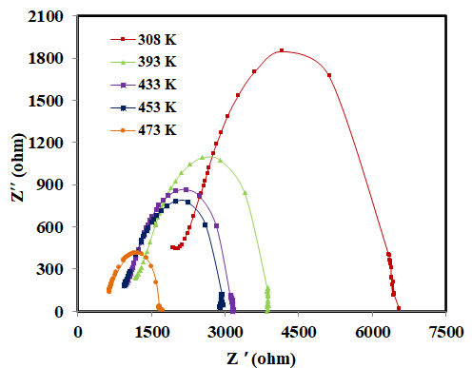
Fig. 3. Cole–Cole plot of 40 mol % of P₂O₅.
The DC resistance of the samples is obtained from the intersection of the semicircle with the real axis at low frequency. The intercepts of the semicircle shift towards the origin with temperature. Using sample dimensions the DC conductivity (σ_{dc}) was calculated which is increases with increasing temperature that is with the increase in temperature, the bulk resistance of the sample decreases and the electrical conductivity shows a gradual enhancement that is activated conduction mechanism. The reciprocal temperature dependence of the DC conductivity is shown in Fig. 4. The plot shows that the DC conductivity exhibits an Arrhenius-type temperature dependence given by the relation
$$σ_{dc}=σ_{0}\exp\left(-\frac{E_{dc}}{KT}\right) ------(1)$$
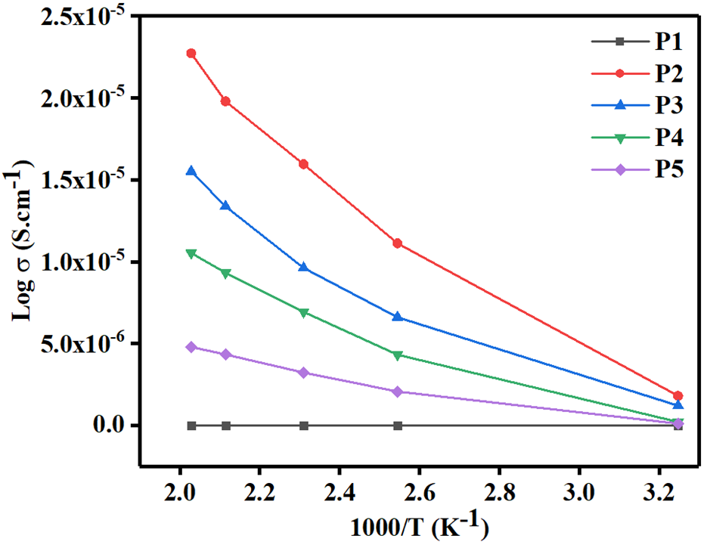
Fig. 4. Temperature dependent DC conductivity
The nature of log σ with log ω was observed for P2 glass samples, as shown in fig. 5. It shows that, for low frequency, conductivity is almost frequency independent since electrons hopping overcome in this range, while at higher frequency it is almost frequency dependent and increases in a power law fashion and attains linearity at upper frequencies. It indicates dispersion in conductivity, which is greater at decrease frequencies [14, 15]. Normally, the conductivity will increase constantly as much as the phonon frequency [16]. It was explained from the Almond-West power law.
$$σ\left(ω\right)=σ\left(0\right)+Aω^{S}----(2)$$
where σ(0) is the zero frequency limit of σ(ω), ω is angular frequency, S represents the fractional exponent and it decides the kind of charge transport which specifies the ionic/non-ionic boundary and also the dimension of the conduction [17, 18]. The value of S reliant on material and temperature, which changes from 0 to 1. A is a weakly temperature-dependent quantity, and it is constant. Aω^{S} is the pure dispersive component of AC conductivity having a characteristic of power law in terms of angular frequency ω and exponent S that represents the degree of interaction between mobile ions and the lattices around them. It is clear that conductivity is dependent on ω^{S} in high frequency regime. The frequency exponent (S) lies in between 0.4 and 0.7. The temperature dependence of the frequency exponent, for the investigated glass samples is shown in fig. 6. From figure it is clear that, correlated barrier hopping (CBH) conduction mechanism is predominant for all glasses as, s decreases with increase in temperature [14]. The behavior of S indicates that the correlated barrier hopping is the possible conduction mechanism in the present glass samples [19].
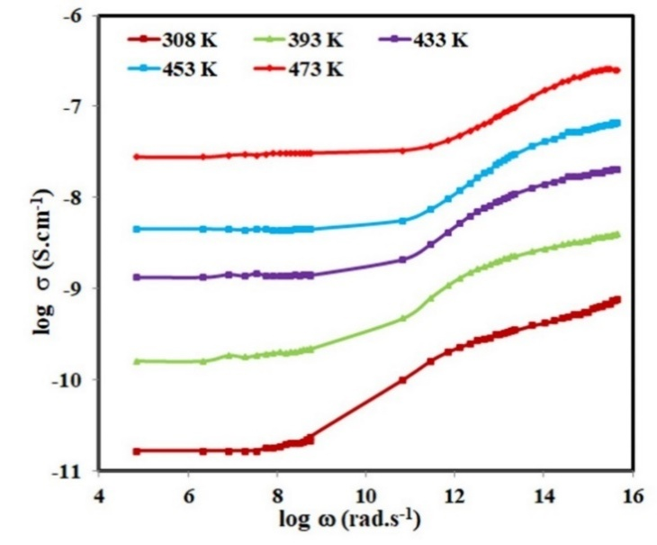
Fig. 5. Frequency-dependent conductivity plot of 40 mol % of P₂O₅.
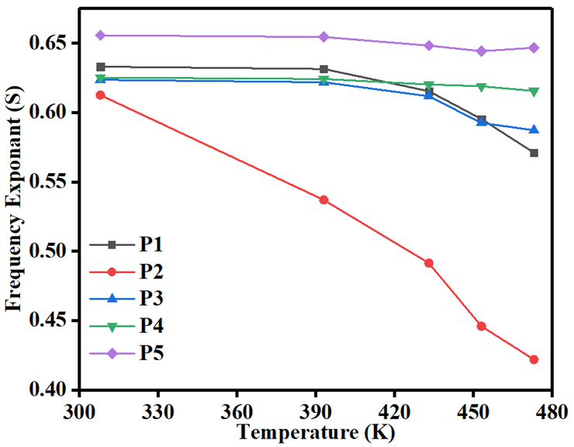
Fig. 6 Plot of frequency exponent (s) with temperature.
The maximum barrier height (R) was calculated by using Eq. (3) as [20]:
$$R=\frac{6KT}{1-S} ----(3)$$
where K is the Boltzmann constant, and T is the absolute temperature. The values of R for all samples were listed in Table 1. The maximum barrier height (R) increases with temperature whereas decreases with increasing P₂O₅ as shown in fig. 7.
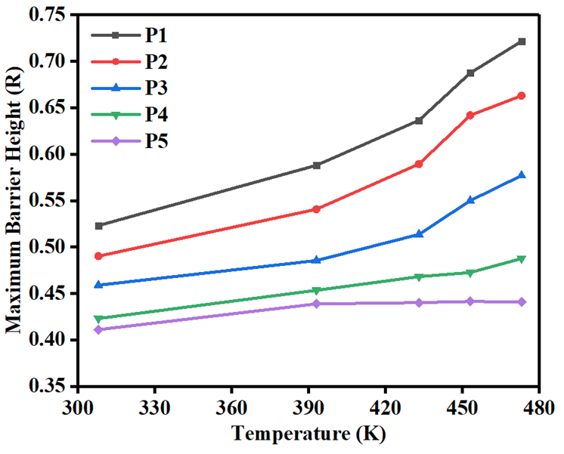
Fig.7. Variation of maximum barrier height (R) with temperature.
Table 1: Frequency exponent (S) and Maximum barrier height (R) for all glass samples
Temperature (K) | Frequency exponent (S) |  |  |  |  | Maximum barrier height (R)
Temperature (K) | P1 | P2 | P3 | P4 | P5 | P1 | P2 | P3 | P4 | P5
308 | 0.633 | 0.613 | 0.624 | 0.625 | 0.656 | 0.523 | 0.490 | 0.459 | 0.423 | 0.411
393 | 0.631 | 0.537 | 0.622 | 0.624 | 0.654 | 0.588 | 0.541 | 0.486 | 0.453 | 0.439
433 | 0.615 | 0.491 | 0.612 | 0.620 | 0.648 | 0.637 | 0.589 | 0.514 | 0.468 | 0.440
453 | 0.595 | 0.446 | 0.593 | 0.619 | 0.644 | 0.687 | 0.642 | 0.550 | 0.473 | 0.442
473 | 0.571 | 0.422 | 0.587 | 0.616 | 0.646 | 0.722 | 0.663 | 0.577 | 0.488 | 0.441

Fig. 8 shows the variations in AC conductivity with frequency for all glass samples at a temperature of 473K. The glass sample P2 shows the highest conductivity of 9.29×10⁻⁴ S.cm⁻¹, which is due to dipole polarization which is the characteristic property of disordered materials. The decrease in conductivity beyond P2 may be due to the elimination of the non-bridging oxygens and simultaneously creates bridging oxygens.
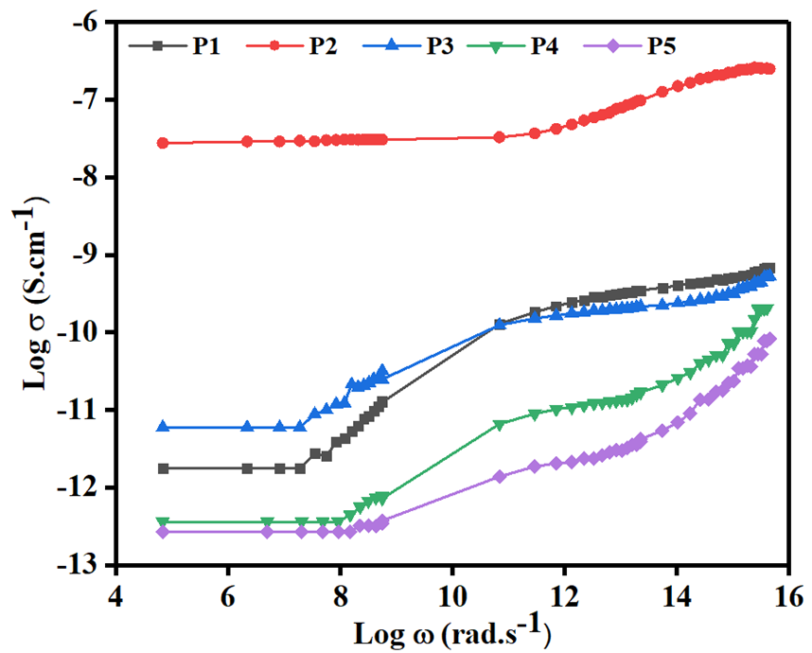
Fig. 8. Conductivity plot of all glass samples.
We tabulate the values of AC conductivity at several frequencies and temperatures. The new parameter figure of merit F related to the response time, which represents the relationship between the dielectric permittivity and the AC conductivity was defined by using Eq. (4). The material having higher value of F is more suitable for solar cell applications [20]. The values of $σ_{ac}$, $ε^{'}$ and F are listed in Table 2.
$$F=\frac{σ_{ac}}{ε^{'}} ------(4)$$
The dielectric constant ($ε^{'}$) and ($ε^{''}$) were estimated from experimental values of capacitance and dissipation from the following relation:
$$ε^{'}=\frac{C}{C_{0}} ------(5a)$$
$$ε^{''}=ε^{'}D -----(5b)$$
Here $ε^{'}$ and $ε^{''}$ are real and imaginary dielectric constant, C is capacitance of materials, C₀ is capacitance of free space and D represents the dissipation factor.
The $ε^{'}$ depends on frequency for P2 at various temperatures is shown in fig. 11. A robust frequency dispersion is detected in lower frequency region, and it is almost frequency independent in the higher frequency region. Also, the values of $ε^{'}$ increase with temperature, which is different for different frequencies. For low frequency region, the larger values of $ε^{'}$ can be explained by the Maxwell–Wagner model [21]. In low frequency region, the influence of high dielectric constant is mainly due to the grain boundaries which was recommended by Koops's model. At a high frequency region, $ε^{'}$ is small, which suggests that, the dielectric nature of the sample is conquered by the grains. The reduction in $ε^{'}$ with frequency is recognized by the electrical relaxation processes [22].
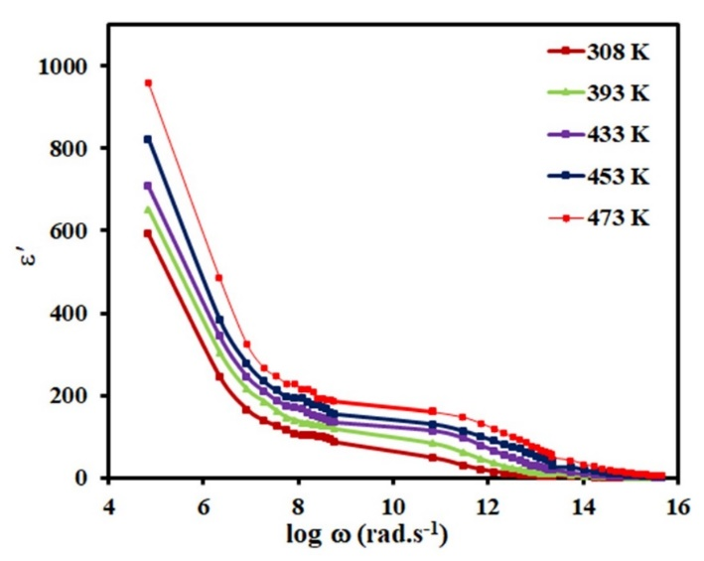
Fig. 11 Plot of $ε^{'}$ as function of frequency for 40 mol % of P₂O₅.
The ${ε'}^{'}$ vary with frequency for P2 at various temperatures is depicted in fig. 12. From this plot, it is seen that in higher frequency portion, ${ε'}^{'}$ exhibits the loss peak because of the polarization of the samples, which obeys the Debye model [23]. Temperature dependence dielectric relaxation peak (ω_{m}) obeys Arrhenius behavior. The dielectric relaxation is mainly due to the hopping mechanism of charge carrier transport.
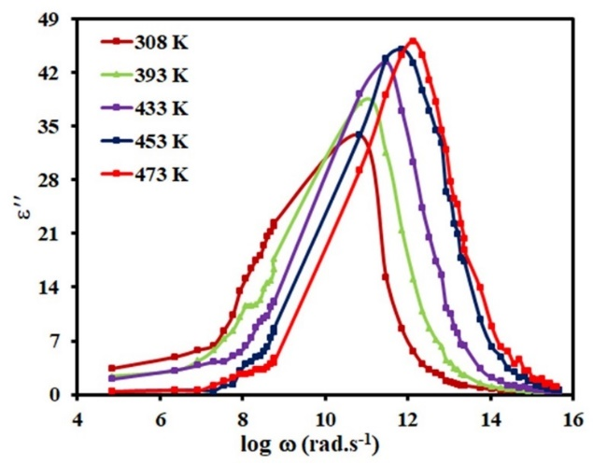
Fig. 12. Plot of ${ε'}^{'}$ as function of frequency for 40 mol % of P₂O₅.

Table 2: Dielectric constant (ε’), AC conductivity (σ_{ac}) and figure of merit (F) for 40 mol % (P2) P₂O₅.
Frequency  (kHz) | ε’ |  |  |  |  | σ_{ac} (S.cm⁻¹) |  |  |  |  | F (S.cm⁻¹)
Frequency  (kHz) | 308 K | 393 K | 433 K | 453 K | 473 K | 308 K | 393 K | 433 K | 453 K | 473 K | 308 K | 393 K | 433 K | 453 K | 473 K
1 | 85.65 | 118.49 | 160.81 | 172.00 | 216.67 | 1.05×10⁻⁵ | 6.34×10⁻⁵ | 1.42×10⁻⁴ | 2.92×10⁻⁴ | 3.1×10⁻⁴ | 1.23×10⁻⁷ | 5.35×10⁻⁷ | 8.82×10⁻⁷ | 1.7×10⁻⁶ | 1.43×10⁻⁶
100 | 2.30 | 8.91 | 19.49 | 42.70 | 42.86 | 3.78×10⁻⁵ | 1.76×10⁻⁴ | 3.47×10⁻⁴ | 6.28×10⁻⁴ | 6.62×10⁻⁴ | 1.64×10⁻⁵ | 1.97×10⁻⁵ | 1.78×10⁻⁵ | 1.47×10⁻⁵ | 1.54×10⁻⁵
1000 | 1.06 | 1.32 | 1.87 | 3.26 | 3.25 | 6.84×10⁻⁵ | 2.23×10⁻⁴ | 4.57×10⁻⁴ | 9.14×10⁻⁴ | 9.29×10⁻⁴ | 7.22×10⁻⁴ | 1.69×10⁻⁴ | 2.44×10⁻⁴ | 2.81×10⁻⁴ | 2.86×10⁻⁴

- Conclusion
The glass samples were synthesized via the well-known melt quenching method. The AC conductivity of glass obeys power law. Semicircular behavior of Z’ and Z’’ suggests that it obeys non- Debye type relaxation, indicating an electronic type of conduction mechanism. The results suggest that, sample is greater conductive at the higher temperature. This semicircle was fitted using a parallel RC circuit. The value of the frequency exponent and its temperature dependence confirmed the applicability of the CBH model. Application of the CBH model clearly specifies that the electronic conduction takes place by single polaron and bi-polaron hopping processes. The dielectric constant decreases with frequency and temperature. The $ε^{'}$increase with temperature and decrease with frequency. In the low frequency area, the larger values of $ε^{'}$can be described by the Maxwell–Wagner model. At a upper frequency region, $ε^{'}$ is constant and small, which recommends that, the dielectric behavior of glasses is conquered by the grains.
Acknowledgements
The author expresses gratitude to the Principal, Government Polytechnic. Amravati, Director, Govt. Vidarbha Institute of Science and Humanities, Amravati; Head, Department of Physics, Govt. Vidarbha Institute of Science and Humanities, Amravati; and Head, Department of Physics, Sant Gadge Baba Amravati University, Amravati for providing the necessary facilities for the research.
References
[1] S. Afyon, F. Krumeich, C. Mensing, A. Borgschulte and R. Nesper, “New High-Capacity Cathode Materials for Rechargeable Li-ion Batteries: Vanadate-Borate Glasses”, Sci. Rep., 4, 7113, 2014.
[2] F. Zheng, M. Kotobuki, S. Song, M. O. Lai, and L. Lu, “Review on solid electrolytes for all-solid-state lithium-ion batteries”, J. Pow. Sour., 389, 198–213, 2018.
[3] A. Alkhazali, M. Etier, M. Aljarrah, A. Alsukker and F. Salman, “An intensive study on the AC impedance mechanism of (AgPO₃)1-x(Ag₂SO₄)x ionic glass systems under various conditions”, Worl. J. Engi., 16(4), 477–486, 20169.
[4] S. Thirumaran and J. E. Jayakumar, “Ultrasonic and spectroscopic studies on structural elucidation of some vanadium glasses”, Res. J. Phys., 8 (1), 1–6, 2014.
[5] G. V. Honnavar, K. P. Ramesh, and S. V. Bhat, “Role of crystal field in mixed alkali metal effect: electron paramagnetic resonance study of mixed alkali metal oxyfluoro vanadate glasses”, J. Phys. Chem. A 118 (3), 573-578, 2014.
[6] B. Getachew, K. P. Ramesh, and G. V. Honnavar, “Nickel ferrite doped lithium substituted zinc and niobo vanadate glasses: thermal, physical, and electrical characterization”, Mater. Res. Expr., 7 (9), 095202, 2020.
[7] B. G. Hailemariam, G. V. Honnavar, M. Irfan I, and R. Keralapura, “Structural and electrical properties of lithium substituted niobo vanadate glasses doped with nickel ferrite”, AIP Advan., 11, 035210, 2021.
[8] M. Rioux, Y. Ledemi, J. Viens, S. Morency, S. A. Ghaffari, and Y. Messaddeq, “Optically-transparent and electrically-conductive AgI–AgPO₃–WO₃ glass fibers”, RSC Advan., 5 (50), 40236-40248, 2015.
[9] S. B. Kolavekar, N. H. Ayachit, V. Pattar, and R. V. Anavekar, “Transport properties of phospho-vanadate glasses containing bismuth”, AIP Conf. Proc., 1731, 070029, 2016.
[10] P. Varasteanu, C. Romanitan, I. Bratosin, N. Djourelov, R. Gavrila, A. Radoi and M. Kusko, “Exploring the impact of MoS₂ on the performance of the planar solid micro-supercapacitor”, Mater. Chem. Phys., 21, 124490, 2021.
[11] J. R. Macdonald and E. Barsoukov, Impedance Spectroscopy: Theory, Experiment, and Applications (2005) Wiley, New York.
[12] R.V. Barde, S.A. Waghuley, “Preparation and electrical conductivity of novel vanadate borate glass system containing graphene oxide”, J. Non-Cryst. Solid., 376, 117–125, 2013.
[13] R.V. Barde and S.A. Waghuley, “Study of AC electrical properties of V₂O₅–P₂O₅–B₂O₃–Dy₂O₃ glasses”, Ceram. Inter., 39, 6303–6311, 2013.
[14] V. C. Veeranna Gowda and R. V. Anavekar, “Electrical conductivity studies of AgI–Ag₂O–B₂O₃–TeO₂ glasses”, J. Mater. Sci., 42, 3816–3824, 2007.
[15] R.V. Barde, K.R. Nemade and S.A. Waghuley, “Impedance spectroscopy study of the AC conductivity of sodium superoxide nanoparticles doped vanadate based glasses”, Mater. Sci. for Ener. Techn., 4, 202–207, 2021.
[16] D. Biswas, A. S. Das, R. Mondal, A. Banerjee, A. Dutta, S. abi, D. Roy and L. S. Singh, “Structural properties and electrical conductivity mechanisms of semiconducting quaternary nanocomposites: Effect of two transition metal oxides”, J. Phys. and Chem. of Solids, 144, 109505, 2020.
[17] P. N. Rao, E. Ramesh Kumar and B. Appa Rao, “Structural, electrical, and transport number studies of AgI-doped silver borotellurite fast ion conducting glass system”, Ionics, 24(19), (2018), https://doi.org/10.1007/s11581-018-2550-2.
[18] A.K. Jonscher, Dielectric Relaxation in Solids, (1983) Chelsea Di Electrics, London.
[19] C. Doharea, M.M.A. Imran and N. Mehta, Study of dielectric relaxation and thermally activated a.c. conductionin glassy Se70Te30and Se70Te28M2(M = Ag, Zn and Cd) alloys, Journal of Asian Ceramic Societies 4, 252–258, 2016.
[20] H. Bouaamlat, N. Hadi, N. Belghiti, H. Sadki, M. N. Bennani, F. Abdi, T. Lamcharfi, M. Bouachrine, and M. Abarkan, Dielectric Properties, AC Conductivity, and Electric Modulus Analysis of Bulk Ethylcarbazole-Terphenyl, Adv. Mate. Sc. and Eng., (2020), Article ID 8689150, 8 pages.doi:10.1155/2020/8689150.
[21] T. I. Koba, T. Wagner, P. J. S. Ewen and A. E. Owen, “Index of refraction of Ag-doped As₃₃S₆₇ films: Measurement and analysis of dispersion”, Philos. Mag. B, 71, 311–318, 1995.
[22] N. Chandel, M. M. A. Imran and N. Mehta, “Comprehensive studies of temperature and frequency dependent dielectric and a.c. conducting parameters in third generation multi-component glasses”, RSC Adv., 8, 25468, 2018.
[23] F.A.A. Wahab and M.A. Baki, “Electrical conduction and dielectric properties of lithium aluminium silicate glasses doped with Cr³⁺ ions”, J. Non-Cryst Solids, 355, 2239–2249, 2009.

