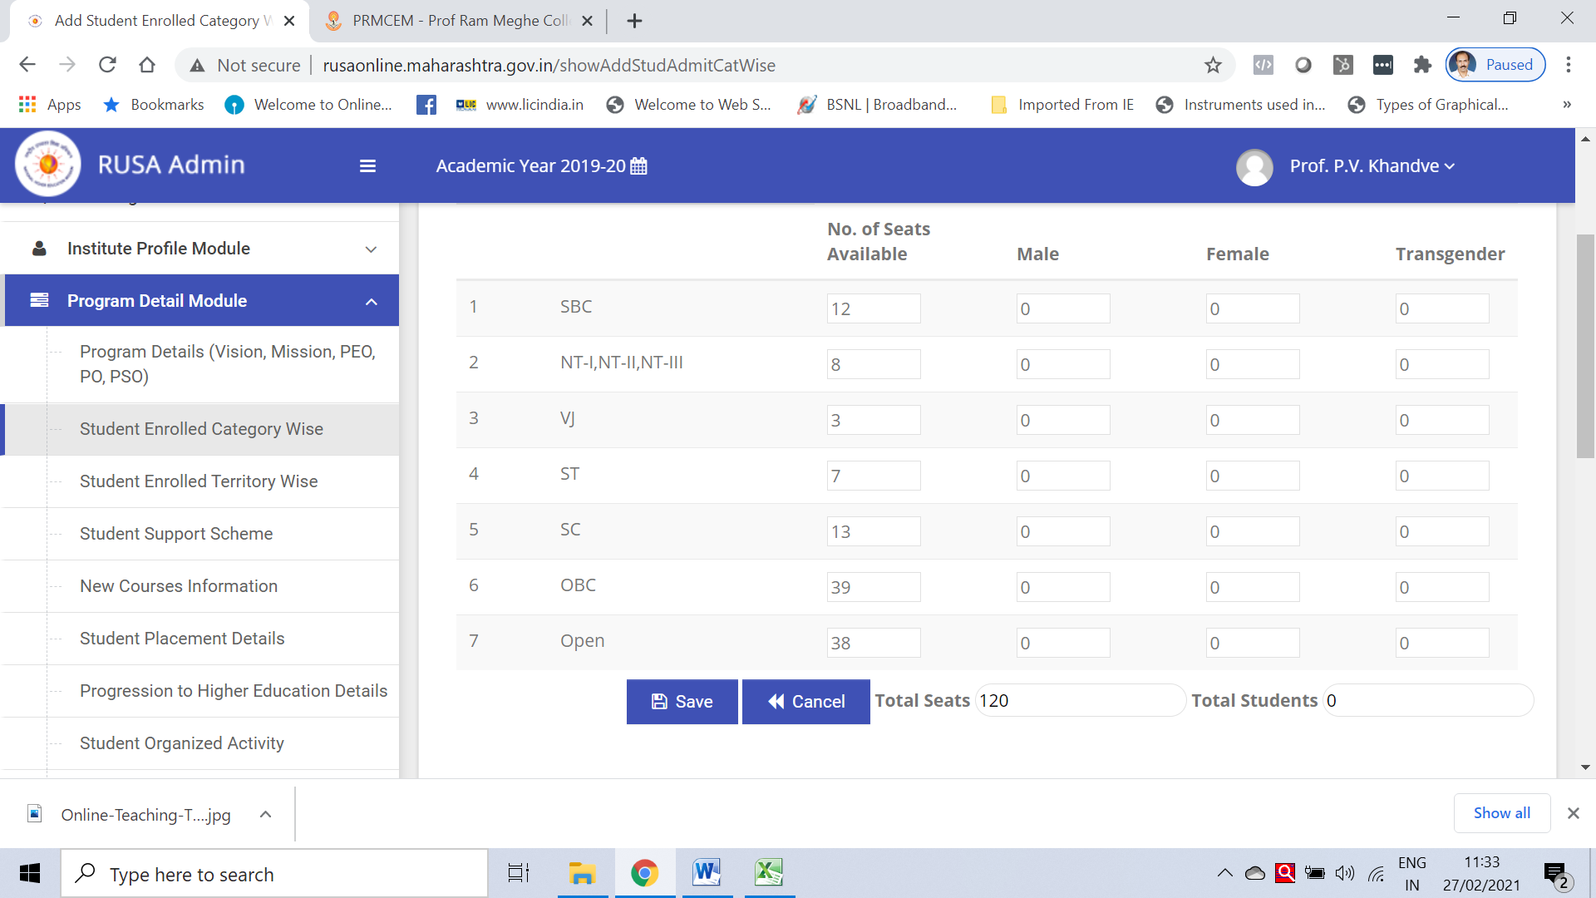

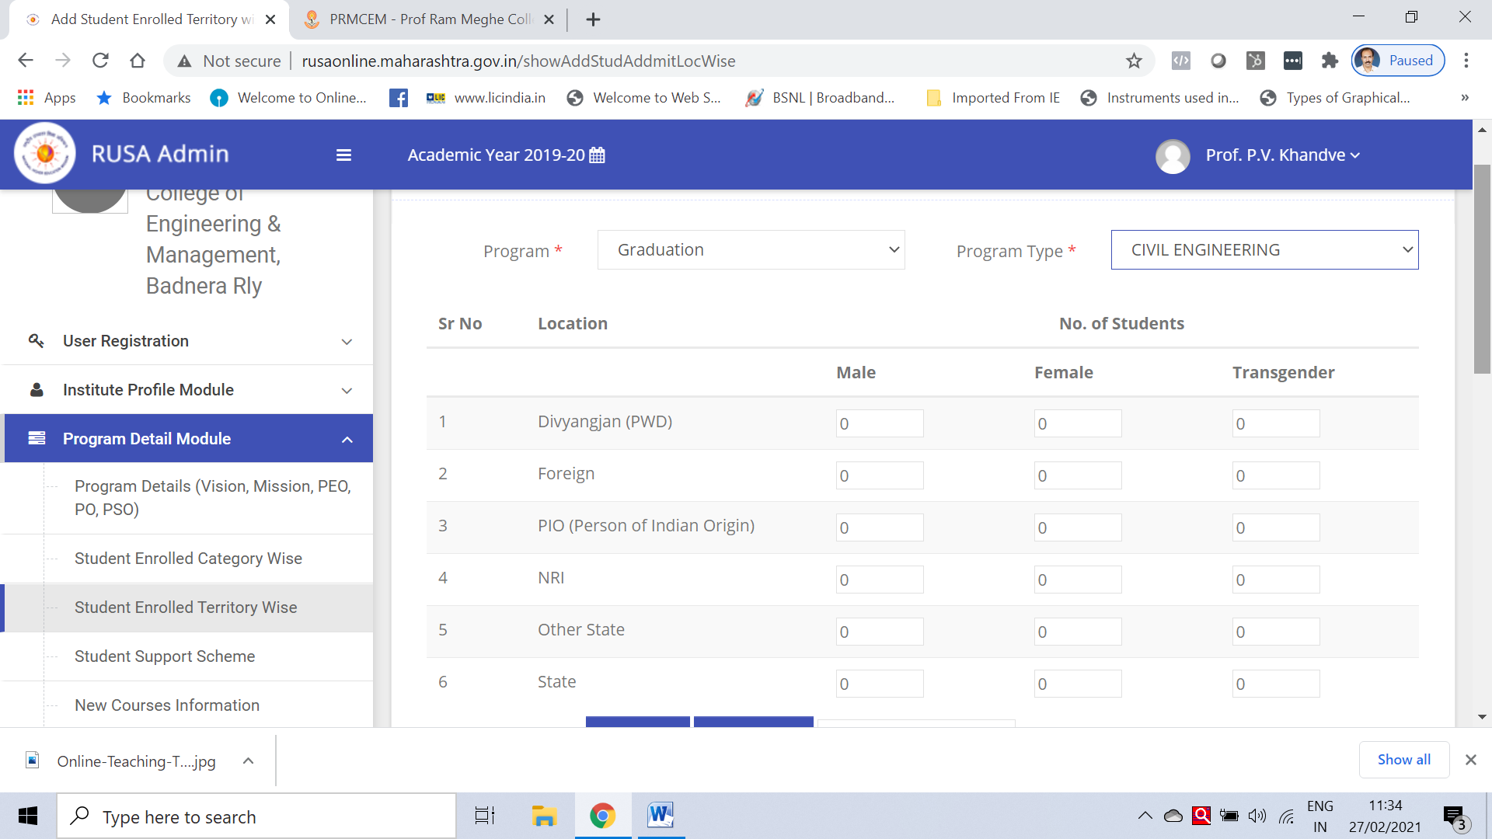

Final year student appeared and pass % and count
Student appeared for Gate and pass student
Internship details 2019-20

To solve different problems associated with civil engineering field by providing solutions based on practice and research
To achieve excellence in design and analysis of various civil engineering structures.
To Improve engineering designs based on

To solve civil engineering problems in different scenarios there by making them successful in engineering practice and/or research or in other fields they choose to pursue.

2. To achieve expertise in design and analysis of various civil engineering structures.

3. To generate engineering designs that are based on sound principles which considers functionality, aesthetics, safety, cost effectiveness and sustainability.

4. To function ethically in professional civil engineering roles and exhibit good competency in their work culture.

5. To enhance lifelong learning by being active members of professional bodies like
ICI, ISCE, ASCE etc. and obtain professional licensure.

